
Dear Parents / Carer
At St Cecilia’s Catholic Junior School we are fortunate that the majority of parents and carers appreciate that educating our pupils involves partnership between all of the school community. A good working partnership is important to equip pupils with the necessary skills for adulthood and we welcome and encourage parents and carers to fully participate in the life of our school.
Unfortunately, the behaviour of a minority of parents and carers can impact negatively upon the good working partnership. We believe that all school staff, parents, carers and pupils are entitled to a safe and protective environment in which to learn and work. The purpose of this letter is to provide a reminder of the conduct expected from all visitors to our school.
Disruptive behaviour
For many of us this may come as a surprise, however a third of schoolteachers nationally have suffered abusive behaviour from parents and carers in the past. We firmly believe that all members of the school community have the absolute right to work and be in school without fear of aggression or abusive behaviour from parents and carers. Such behaviour can be through face to face contact, in written communications, on the telephone or by the use of social media and can present a risk to staff and pupils. To support a safe school environment, we cannot tolerate parents, carers or visitors who exhibit any of the following behaviour:
• Use of loud and/or offensive language or display temper
• Threaten to carry out actual bodily harm to any other person on school premises
• Damage/destroy school property
• Intimidate any other person on school premises
• Make vexatious or malicious allegations against a member of the school community, either in writing or via direct contact verbally
• Insult any member of the school community in an attempt to demean or undermine
The above list is not exhaustive and any individual exhibiting disruptive or unreasonable behaviour will be considered in accordance with the school’s Code of Conduct (which can be accessed via the school website at https://www.stceciliasjuniorschool.co.uk/policies/). The school may ultimately decide to impose restrictions on an individual when entering the school premises including a ban from school entirely, which may also extend to non-admittance to school events such as pupil plays/assemblies and communications restricted to writing or via a third party.

The use of social media for parents’ views
Whilst we appreciate the right to freedom of speech and recognise the benefits of using social media, unfortunately on occasions we experience situations where members of the school community use social media to exhibit inappropriate behaviour.
It is further appreciated that social media users may be of the opinion that their postings are ‘private’. However, once a comment is posted other social media users can forward/share such views. If postings are considered to be threatening or discriminatory, the school may have to refer the matter to the Police and report it to the social media provider. Given the above we ask you never to refer to individual pupils or any member of school staff on social media and we respectfully refer all members of the school community to our Social Media Policy which can be accessed via https://www.stceciliasjuniorschool.co.uk/policies/.
It is recognised that parents and carers may not always agree with a particular course of action taken by the school or may have concerns in respect of the school community. We welcome constructive feedback and encourage concerns to be discussed with the relevant person in the school in the first instance. Any complaints which cannot be resolved in this manner should be channelled via our school’s complaint policy which can also be accessed via https://www.stceciliasjuniorschool.co.uk/policies/.
In connection with a city-wide drive to tackle disruptive behaviour and social media issues, this letter is provided to our school community with support from the Chair of Governors, Merseyside Police and Liverpool City Council. We encourage parents and carers to promote positive role models in both the real and digital world. We seek to provide a safe and protective environment in which they can learn and school personnel can work.

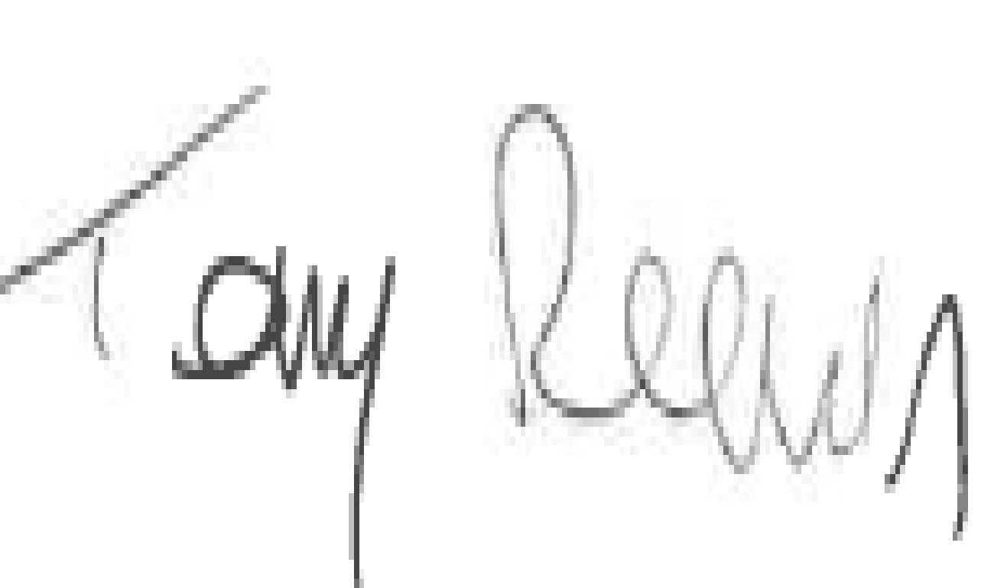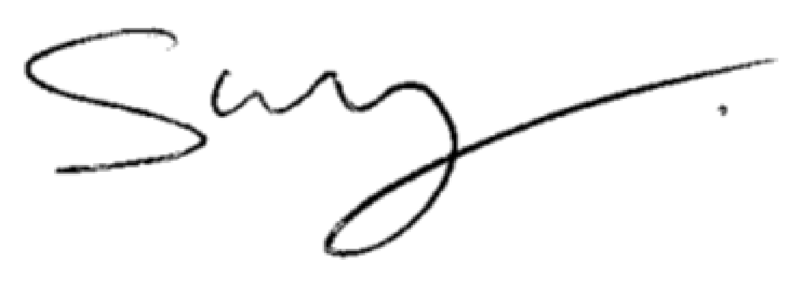
Tony Reeves Steve Reddy
Chief Executive Director of Children and Young People’s Services
Liverpool Liverpool

Diane Pownall
Supt Liverpool Community Policing LP Command


