Making an application for Free School Meals

Dear Parents/Carers,

Please follow the guidance below to check if your child is eligible for free school meals.
The following instruction is to assist parents and carers who wish to make a claim for Free School Meals (FSM). All applications for FSM must be made via the Citizen Portal. The application process is for all children from Nursery to Year 6 and is quick and easy to do.
The Citizen Portal can be accessed from the Liverpool City Council Website by accessing the link below:
www.liverpool.gov.uk/benefits/free-school-meals/
Before making an application, users must have an account set up. In most cases the parent/carer of a child will already have a Citizen Portal account as this will have been used to register children for admissions.
If the username or password has been forgotten, please follow the onscreen instructions to reset your account.

Checking your family on the Citizen Portal
- Log into Citizen Portal

- You check the details of the children you have already registered in the portal in the My Family section, and you can also add new children here.

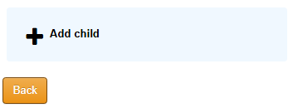

How to make an application for Free School Meals
- From the first screen, select the Free School Meals Icon


