St Cecilia’s Catholic Primary School

Educational Visits Policy


“With Jesus as our guide and walking by our side,

we learn to love and love to learn.”
Date of policy : |  | March 2026 |  |  | Reviewed:
Educational Visits Lead: C. Patterson
Signed by:
S. Hurst | Headteacher |  | Date: | March 2026
J. Kilburn | Co Chair of governors |  | Date: | March 2026
L. Fogherty | Co Chair of governors |  | Date: | March 2026

Educational Visits Policy
Overview
At St Cecilia’s Catholic Primary School Equal Opportunities plays an integral part in all aspects of teaching and learning. The school acknowledges the great value of educational visits in broadening and enhancing both the learning and social experience of young people. Children should go on a variety of school visits whilst they are pupils at this school. Ideally visits will support the work in the classroom and should occur as often as practically possible, at least once per term.
Educational Visits Co-ordinator (EVC), will ensure that the planning and supervision of all visits and adventurous activities meet the DfE Requirements and LA guidelines.
The School Improvement Liverpool Educational Trips Policy is adhered to when planning trips and is available on our website. This policy runs along side that document with information pertinent to St Cecilia’s school specifically.

Before the Visit:
1a) Visit leader to discuss the proposal with the Headteacher and complete the Educational Visit Checklist. (on EVOLVE)
If approved:-
2) Book Visit.
3) Arrange appropriate transport.
4) Complete all relevant documentation eg Risk Assessments as per process on EVOLVE. A visit to the venue by Group leader is advisable, if a new school trip.
5) At least two weeks before let the kitchen know exactly how many packed lunches you will require for children that are eligible for free school meals.
6) Send a letter to parents with a permission slip, specific to your outing.
7) Arrange for parents and helpers to accompany on the outing (if required).

Assessment of Risk
‘Risk assessment’ is a careful examination of what could cause harm to pupils/participants, staff or others, together with an identification of the control measures necessary in order to reduce risks to a level which, in the professional judgement of the assessor, is deemed to be acceptable (i.e. low).
In considering risk, there are 3 levels of which visit leaders should be mindful:
1) Generic Risks – normal risks attached to any activity out of school.
2) Event Specific Risk – any significant hazard or risk relating to the specific activity and outside the scope of item 1.
3) Ongoing/Dynamic Risk – the monitoring of risks throughout the actual visit as circumstances change

Approval for Visits
All matters regarding each visit off site – feasibility, planning, safety, organisation etc – will require the prior approval of the EVC and then to be signed off by the Headteacher.
Approval of ‘normal’ day visits are at the discretion of the Headteacher. However, visits that are either:
• residential or
• a visit involving an adventurous activity will require the additional approval of the LA (online through EVOLVE). The governing body will also need to be informed about these visits prior to a commitment being made.
• if an external provider or tour operator is being used, they must complete the detailed Form EV4 (External Provider Form) at the time of the provisional booking.
Plan ‘B’
Despite the most detailed and meticulous pre-visit planning, things can go wrong on the day, e.g. parent helper is unavailable, member of staff is ill, transport fails to arrive, museum have lost booking etc.
To avoid having to make important decisions under pressure, it is important that some advanced thinking is done to cater for any foreseeable eventuality.
Parent Helpers
All parent helpers should read ‘Keeping Children Safe in Education’ prior to the trip and sign to say they have understood the information.
First Aid
The level of first aid provision should be based on risk assessment. On all visits, there should be a member of staff who has a good working knowledge of first aid. The One Day Emergency First Aid Work for the appointed person is the minimum requirement for residential visits and specific Pediatrics or Activity First Aid qualifications may be needed for Early Years or Adventurous Activities.
First aid kits are available from the Admin Office; if the visit involves the party splitting up by any distance, a kit should be taken for each group.
Transport
Travel arrangements should be included in the risk assessment. If travel is by coach or minibus, all pupils/participants must wear a seat belt. If a minibus is being utilised the driver must have the appropriate LA driving permit / minibus licence.
Water ‘Margin’ Activities
Where pupils/participants might participate in learning activities near or in water, such as a walk along a riverbank or seashore, collecting samples in ponds or streams, or paddling or walking in gentle, shallow water, then the guidance contained in ROSPAs ‘Group Safety at Water Margins’ is relevant. All staff, including parents, should be provided with a copy of this guidance prior to the visit. A copy of this is downloadable from EVOLVE.

Cost
In line with the schools Charging and Remissions Policy it may necessary to ask for donations towards a visit, to be conducted during the normal school day, in order to cover the cost of transport / entrance fees etc. For residential activity visits, costs will be calculated to cover any board, lodgings, transport and activities as planned.
Seeking Parental Consent
Parents should be made fully aware of any likely risks of the visit and their management, so they may consent or refuse on a fully informed basis (known as ‘Acknowledgement of Risk’).
The letter to parents should therefore give full detail of the visit, the reason for the visit (educational aims), supervision arrangements and the transport arrangements. Ensure that detail of other incidental activities is included, together with Plan B if appropriate. The letter should also state the cost of the visit per child: parents/carers are to pay for visits via School Money.
The reply slip should read:-
“I give permission for my child to take part in ….. I have read and understand the information about the visit.”
In the case of sports fixtures, the reply slip should read:-
“My child is able to play in the ……. match (at ……..) on ………..
I have read and understand the information in the letter, and give permission for my child to take part.”
Emergency Procedures
All staff involved in a visit should be aware of what action to take in the event of an emergency.
Ensure the rest of the group are safe, decide if you need specialist help and either; contact the school, emergency services and/or parents (liaise with onsite First Aiders). For visits that take place outside of school hours the mobile phone number of the staff nominated as “home” contact must be with the leader at all times.

Advice and guidance
The schools Health and Safety advisor can be contacted for any matter concerning off site visits and experiential learning and can also advise on all matters concerning safety.
Ratios
The staffing required to run the visit safely needs to be identified and should take the following factors into account:
• Gender, age and ability of group.
• Pupils with special education needs or medical needs.
• Nature of activities.
• Experience of adults in off-site supervision.
• Duration and nature of journey.
• Type of any accommodation (if applicable).
• Competence of staff, both general and on specific activities.
• Requirements of the organisation/location to be visited.
• Competence and behaviour of pupils.
The following is provided by School Improvement Liverpool and highlights the minimum ratio acceptable on any visit:

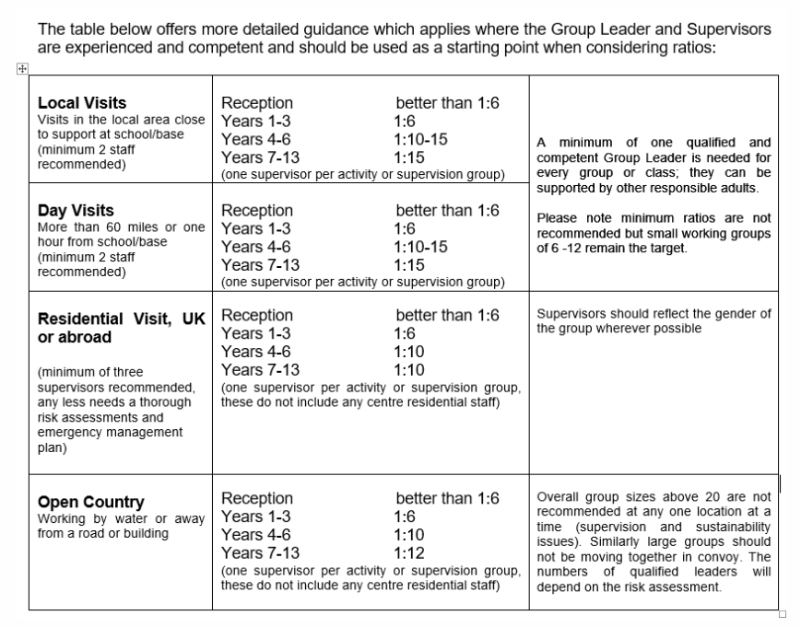

Procedure on the day:
• Collect packed lunches from the kitchen.
• Check the first aid outing bag to make sure it is adequately equipped. Make sure that individual pupils that have their own medicines, have adequate supplies etc (pumps etc).
• Share the risk assessment with all adults going on the trip.
• Discuss with children behaviour expectations.
• Organise the children into groups. Each adult should take responsibility for a small group of children but 2 adults and their groups should stay together.
• Inform everybody of possible hazards (risk assessment), e.g. deep water, major roads, etc.
Make sure everyone knows the pick-up point and leaving time.
• Make sure all the children go to the toilet before leaving.
• Take money/card and mobile phone for use in emergency.
Never label children with their name. If a group of children need identification, then the name of the school and telephone number may be used.
• All adults should wear high visibility vests in KS1.

On the minibus bus/coach:
Count children onto the bus.
• Children and adults must wear seat belts.
• Adults must be well spread out - one should sit near the back to keep an overall view.
• Adults should sit on the outer seat.
• Children should not change seats, kneel up, eat, or be allowed to open windows.
• When getting off the bus, an adult should get off first. The children should go to that adult as they get off. The last person off should be an adult, checking that nothing has been left behind.
Count children off the bus.
The class teacher should lead and another staff member should be at the rear. Any other adults
should stay with the children in the middle.
Always walk on the pavement as far away from the road as possible. Adults walk closest to the road.
Children must NEVER step into the road until given permission by an adult.
Mobile phone(s) should be switched on during trip and the School/ Home Contact advised of any delays etc. as soon as possible and updated regularly so they can update waiting parents etc

Returning to School
Update school office with ETA
Day trips returning during the school day - Staff should walk children onto the school playground to allow for safe dismissal.
Residential trip return – staff should carefully position themselves on Green Lane at the doors of the bus to send every individual child safely to the adult waiting to collecting them.
Member of staff to do a thorough bus check for lost property.
Children who are late to be collected – parents should be contacted and trip lead stay with that child until their parent arrives.
Hand trip documentation folder back to the school office.

Incidents during the trip
Accident or injury should be dealt with by First Aiders from the centre visited. If school staff are responsible for the trip, the First aid qualified member of staff will assess and treat the injury. Parents will be contacted if necessary. SLT will be informed accordingly.
Medical injury or incidents needing further assessment should be reported appropriately to parents upon return as per school policy.
Behavioural incidents will be dealt with by visit lead, or for further support, by contacting SLT at school. A decision will then be made if the pupil/ pupils will remain on the trip.
Incidents involving behaviour should be reported to parents either upon return, or at the most convenient opportunity. Staff must add any incidents of concern to CPOMS upon returning to school.

Evaluation
Evaluation of the trip should always take place upon return. Has the trip been a success? Do you consider it to have been suitable for supporting the program of study or intended outcomes? Was the trip value for money? Was the venue suitable? Was transport suitable? Were there any areas needing improvement?
Staff should fill out a trip evaluation form and give to the Curriculum lead responsible for the trip, this allows for changes to be made or a different venue or trip to be considered the following year.



