St Cecilia’s Catholic Primary School

Music Policy
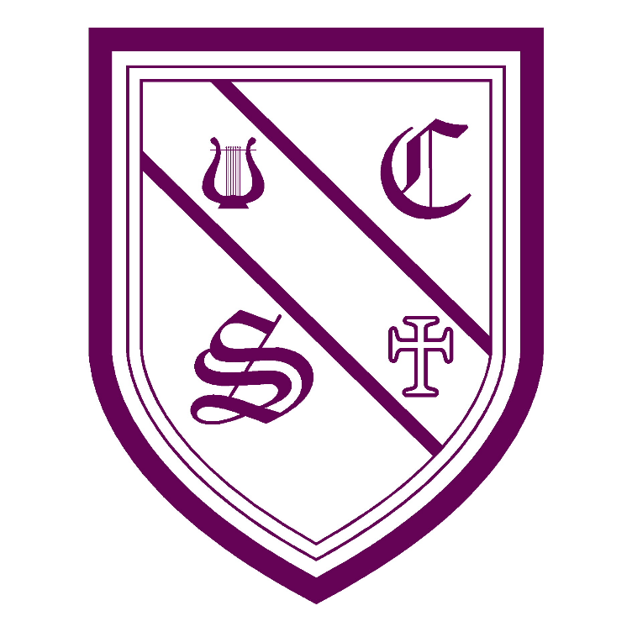

“With Jesus as our guide and walking by our side,

we learn to love and love to learn.”
Date of policy : |  | 07/02/25 |  |  | Reviewed: 04/02/26
Signed by: Miss Hampson
S. Hurst | Headteacher |  | Date:
 | Co Chair of governors |  | Date:
 | Co Chair of governors |  | Date:

Rationale
St Cecilia is the Patron Saint of music and as such, our vision of music celebrates the joy and creativity that music can bring. Music is a universal language that embodies one of the highest forms of creativity, which equips children with a better understanding of the world they live in and enables them to communicate their experiences and feelings. Our pupils are musicians; developing a love of music as well as the skills of performance, critical listening, and composition, whilst they engage with a wide variety of musical genres and participate in a range of musical experiences. The value we place music in enables pupils to reach their full potential, allowing them to become socially, morally, emotionally, intellectually, spiritually and culturally integrated members of society. Music at St Cecilia’s Catholic Primary School gives children the opportunity to enhance their creativity, self-esteem, self-confidence and sense of achievement in a challenging and collaborative environment.

Curriculum Intent:
At St. Cecilia’s Catholic Primary School community, we use Jesus as our role model and everything we do centres around our Mission statement that: ‘With Jesus as our guide and walking by our side, we learn to love and love to learn.
Music is a subject which connects all people through places and experience in this ever-changing world. It is creative, collaborative and challenging subject giving children a strong sense of achievement. At St. Cecilia’s we provide a music curriculum which aims to provide our children with memorable lessons, whilst allowing them to build resilience, build upon skills and prior knowledge with small progressive incremental steps each year. Our intent is to ignite a passion for music, through offering a broad and balanced curriculum with quality, engaging, exciting lessons with our specialist teachers to inspire a love of learning. Throughout the school the children will experience the opportunity to create, play, perform and enjoy music from a range of genres, cultures, artists. We provide all children with the opportunities to play/ learn different instruments, develop the skills to appreciate a wide variety of musical forms and to begin to make judgements about the quality of music; equipping them with skills and knowledge needed preparing them as future citizens of Liverpool and the wider world.

Music is a subject which can be accessed and enjoyed by all, through it being a mostly practical subject. From Early Years, children have an awareness of rhythm, pitch and sounds, which is developed as the children progress when they develop a critical engagement with music, allowing them to compose and increase their creativity and self-confidence. Every child is given the opportunity to develop their musical talents through experiences which are promoted and cherished. At our school, we aim to prepare our children to realise their potential and push their limitations.
Aims and objectives:
Through the teaching of music, we aim to:
- Know and understand how sounds are made and then organised into musical structures.
- Know how music is made through a variety of instruments.
- Know how music is written down and composed.
- Know how music is influenced by time, place and purpose for which it was written.
- Develop the interrelated skills of performing, composing and appreciating music.
- Develop the skill of actively listening.
- To encourage awareness, enjoyment and appreciation of music in all its forms.
- To develop imagination and creativity.
- To experience a diverse range of music.
- To offer opportunities to perform, compose, listen and appraise.
- Develop social skills through co-operation with others in the shared experience of music making.
- To provide children with a secure knowledge of the Music curriculum and musical vocabulary through retrieval practice.
Curriculum:
At St. Cecilia’s Catholic Primary School, our school uses the model music curriculum (national curriculum) for music as the basis for its curriculum planning. While there are opportunities for children of all abilities to develop their skills and knowledge in each teaching unit, the progression planned into the scheme if work means that the children are increasingly challenged as they move through the school.
- In KS1 the children are taught by specialist music teacher Miss Housley who delivers the scheme of work for children using charanga (also informed by the model music curriculum, which we have subscribed too) which is differentiated through support and outcome through the teacher’s delivery. The lessons are delivered on a weekly basis in both years 1 and 2 receiving a minimum of 45 minutes teaching weekly.
- In KS2 music lessons are taught by specialist music teacher Miss Houseley who uses our carefully curated curriculum using the model music curriculum. The lessons from Miss Houseley are received weekly in half term blocks – years 4/5 receiving them the first half of the term and years 3 and 6 receiving them the second half of the term. Each of the classes receiving music lessons from Miss Houseley receive a lesson of 45 minutes a week.
- On the alternating half terms, we are currently delivering music to the alternate year groups using the ‘Rock Steady’ live music lessons on a Friday which last a span of 45 minutes also. This is quality teaching following incremental steps and providing children with the opportunities to learn notation, rhythm, beats, pulse and have the opportunity to perform and sing along themselves.

Teaching and learning style
Music is taught using a variety of teaching and learning styles, to make music an enjoyable learning experience. We use whole-class teaching (to acquire knowledge), group work (to foster collaboration, support and teamwork) and independent work (to promote creativity). We encourage children to participate in a wide range of musical experiences to support building up an appreciation for all music and the confidence of all children.
At St. Cecilia’s Catholic Primary School singing lies at the heart of good music teaching and has become a cross curricular part of our learning, such as times tables songs in maths, praise and worship in RE and even singing in other foundation subjects to help recall key substantive knowledge.
- Our teaching focuses on developing the children’s ability to sing in tune with others and confidently. Through singing songs, children learn about the structure and organisation of music.
- Our Children will be helped to appreciate and understand a wide range of high-quality live and recorded music drawn from a variety of genres and from great composers and musicians as they develop an understanding of the history/origins of music.
- As children get older, we expect them to maintain their concentration for longer periods of time, and to listen to more high quality live and recorded extended pieces of music. Children will be given the opportunity to develop descriptive skills in music lessons when learning about how music can represent feelings and emotions.
- As well as paying attention to small details in the music and recalling sounds, instruments etc. using their aural memory.
- Retrieval is practiced in every lesson. Retrieval of skills, knowledge and vocabulary from previous lesson, term and year.
- We also teach children to experiment with the composition of music, by making music together, understanding music notation and composing pieces with the use of improvisation using the interrelated dimensions of music.
- They will learn how to play tuned and untuned instruments to then play and perform in solo and ensemble contexts, using their voices and playing musical instruments with increasing accuracy, fluency, control and expression

Assessment:
At St. Cecilia’s staff set high expectations for all children and plan to ensure that there are no barriers to every child achieving. Children demonstrate their ability in music in a variety of ways. Our specialist teachers assess children’s work in music by using ongoing formative assessment making informal judgements as they observe during lessons. On completion of a piece of work the teacher assesses the work given written or oral feedback as necessary to inform future progress. Children are also encouraged to self-assess and make judgements on their own or peer’s work. At the end of a topic, the teacher makes a summary judgement about the work of the pupil in relation to national curriculum expectations.

Send pupils

Differentiated quality first teaching is a priority for all pupils in our school including those with SEND. Our accountability as teachers for the progress and development of SEND learners is reflected in our methods to remove barriers to learning by making adaptations to the planning and delivery of music lessons to meet the needs of our SEND learners. We have high aspirations and a clear understanding of our SEND learners’ individual needs which are recorded in pupil profiles visible in all books; we choose and plan activities and experiences for our SEND learners based on these, in order to achieve the best possible outcomes.

In Music we ensure that provision is available for those children who need it. Provision entails children wearing ear defenders, being supported by an adult, awareness of seating arrangements needed to meet the needs of the child and allowing the child to be aware of their own needs in needing a brain break from lesson if overstimulated.

Resources:
Our school provides the children with access to a variety of resources to aid their learning.
- We have a range of Music equipment and resources that can easily be moved around the school. There is a store of instruments in each Key Stage with a range of instruments showing a progression of skills. KS1 outside Miss Grant’s room and KS2 on the balcony.
- Two specialist teachers who teach every week.
- There are a number of tuned instruments (guitars, set of ukuleles)
- Number of untuned instruments
- Access to charanga resources for KS1 staff and Mrs Smith
- Access to some sheet music – and CD’S if needed
Subject Leader Responsibility:
The music subject leader is responsible for supporting the development of music and its provision throughout the school. They will monitor the standard of teaching and learning through learning walks and lesson observations, ensuring that colleagues are supported with the teaching of the subject and relevant CPD is provided. The lead will also seek opportunities to enrich pupils’ learning through educational visits, opportunities for fieldwork and access to resources.

Outcomes
All pupils will benefit from a high-quality music education which will engage and inspire pupils to develop a love of music and their talent as musicians. It will increase their self-confidence, creativity and sense of achievement. As pupils progress, they will develop a critical engagement with music, allowing them to enjoy a wide and rich range of music. They will experience musical pieces from their own and a range of different cultures.

Wider opportunities
Children are offered the opportunity to study a musical instrument with our peripatetic teacher, Ms. Walker. Instruments available to learn are flute, clarinet, recorder and piano. Parents who want their children to participate in extracurricular wood wind lessons in Years 5 and 6 but are unable to provide an instrument are offered the opportunity to apply to the school to use some woodwind instruments owned by the school at no charge. Parents not eligible for this opportunity must purchase or hire an instrument and pay the additional music lessons feed on a termly basis.

Performance
We believe that music enriches the lives of people, and so we wish to involve as many children as possible in musical activities. We have a school choir which we encourage all children from Y3-6 to join. The choir meets on a weekly basis when running in the summer term and, although its primary aim is to enable children to enjoy singing together, it also performs in public on a number of occasions throughout the year for the local community and other schools.
We also provide opportunities throughout the year for musical talent to be showcased to the school and the school community. This includes solo and ensemble performances as part of assemblies and concerts. This recognises their achievements and celebrates their success.
There are weekly hymn practices in KS2 after whole school collective worship assembly, allowing the children to worship through singing. This is also done in some small in class collective worships also.

