 | Autumn 1 | Autumn 2 | Spring 1 | Spring 2 | Summer 1 | Summer 2
 | I will be Healthy ME. |  | I will be Social ME. |  | I will be Thinking ME.
MPB | Resilience, Self-motivation, Responsibility | Courage, Self-discipline, Honesty | Encouragement,  Communication, Trust | Respect, Empathy,  Co-operation | Evaluation, Problem Solving, Curiosity | Decision Making, Reflection, Concentration
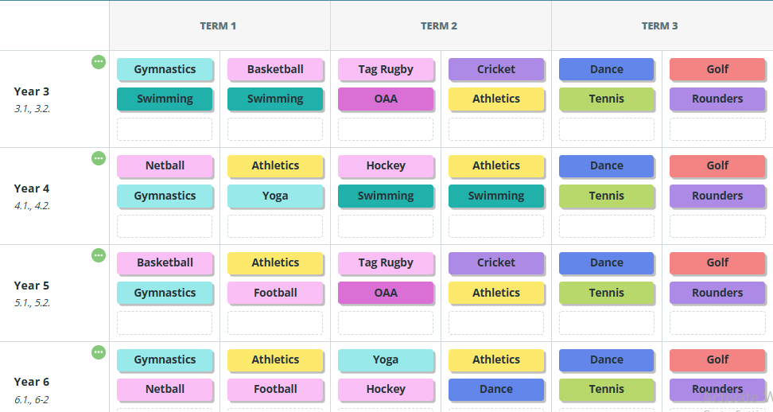

Each class MUST have at least 2 SESSIONS of PE time per week. This can include swimming, dance, PPA sessions with John.
2 x PE sessions (60 mins) = 120 mins | 295 mins or 5 hours  (not including after school clubs, extra sessions etc)
5 x AM breaks = 75 mins
5 x Lunch breaks = 100 mins
The Association for PE recommends that children should be doing 30 minutes physical activity a day in school. This amounts to 2.5 hours.

