
St Cecilia’s Catholic Junior School
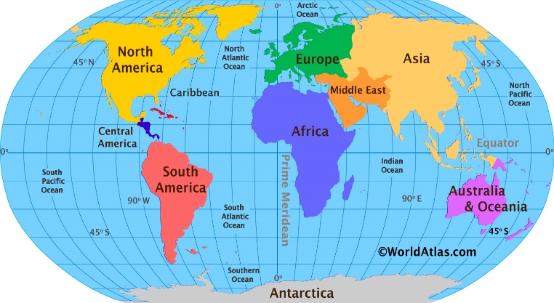

Our Geography Key Concepts

Place
Space
Scale
Environment
Interconnection
Change
Sustainability
Physical & Human Processes

Year Group | Key Concepts Covered
Year 3 | Place, space, environment, physical and human processes
Year 4 | Place, space, environment, physical and human processes, sustainability
Year 5 | Place, space, scale, environment, physical and human processes, sustainability, change
Year 6 | Place, space, scale, environment, interconnection, physical and human processes, sustainability, change
The above geographical concepts are fundamental to the development of geographical understanding. They can be applied across the subject and support children in their ability to think geographically and answer enquiry questions.

Place
The concept of place is about how every place has a particular location and a unique set of physical and human characteristics. What we think about places is both shaped by, and shapes, our ‘geographical imagination’. Pupils will often return to the same place in different years but through a different lens.
To develop a sense of ‘place’, pupils will:
- Have the locational knowledge to describe where they are (including which continent, country, county and city).
- Know that places are parts of the Earth’s surface that are identified and given different meaning by people via patterns, behaviour and communication. They range in size and can be described by their location, shape, boundaries, features and environmental and human characteristics; some of which are tangible (e.g. landforms and people), while others are intangible (scenic quality and culture).
- Know that places are important to our security, identity and sense of belonging. They provide us with the services and facilities to support and enhance our lives and where people live can influence this.
- Know that the environmental characteristics of a place are created, changed and managed by human and environmental processes over varying time periods.
- Know that the human characteristics of a place are influenced by its environmental characteristics, location, connections with other places, culture of its population, economy, and the actions of people/organisations over time and at different scales.
- Know that each place is unique in its characteristics, environmental and socioeconomic processes.
- Understand that the sustainability of places may be threatened by a range of factors (e.g. natural hazards; climate change; economic, social and technological change; government decisions; conflict; exhaustion of a resource and environmental degradation).

Space
The concept of space is about the distribution of physical features, people, services and goods and how they interact.
To develop an understanding of ‘space’, pupils will:
- Understand how natural and man-made places are connected in the world.
- Know that the environmental and human characteristics of places are influenced by their location,
- Know that transport and communication technologies are reducing the effects of place locations on people.
- Understand that the individual characteristics of places form spatial distributions which contribute to geographical understanding. These spatial distributions also have environmental, economic, social and political impacts.
- Know that spaces are perceived, structured, organised and managed by people, and can be designed and redesigned to achieve particular purposes.

Environment
The concept of ‘environment’ refers to the surroundings in which an individual or community functions. It also refers to the different types of environment, each of which have a combination of features, conditions and processes.
To develop an understanding of ‘environment’, pupils will:
- Understand that the environment consists of geological, atmospheric, hydrological, geomorphic, edaphic (soil), biotic and human processes.
- Know that the environment supports and enriches life by providing humans and other living things with the things that they need to survive.
- Know that the environment provides both opportunities for, and constraints on, human settlement and economic development.
- Know that culture, population, economy, technology and values can influence how people perceive, adapt to and use similar environments.
- Know that the management of human impacts on environmental change requires an understanding of the causes and consequences of change and the identification of appropriate strategies.
- Know that each type of environment has its own hazards and that the impact of these hazards is determined by natural and human factors.

Scale
The concept of scale is about the way that geographical phenomena and problems can be examined at different spatial levels.
To develop an understanding of ‘scale’, pupils will:
- Know that generalisations made and relationships found at different scales are not the same. Scale can influence our identity and the way we represent what we see or experience.
- Know that cause and effect relationships can function across different scales.

Interconnection
The concept of ‘interconnection’ is about how every geographical study is connected to another in some way. They cannot be viewed in isolation.
To develop an understanding of ‘interconnection’, pupils will:
- Understand that people and organisations are interconnected with other places in a variety of ways. These interconnections can influence the characteristics of places.
- Environments and human processes are cause-and-effect interconnections which operate between and within places.

Sustainability
The concept of sustainability is about how physical and human processes operate to maintain the quality of the environment and the availability of resources.
To develop an understanding of ‘sustainability’, pupils will:
- Know that sustainability is both a goal and a way of thinking about how to progress towards that goal.
- Understand that sustainability can be influenced by the economy and politics, together with a concern that current practices should not deprive future generations of opportunities to enrich their lives.
- Know that progress towards environmental sustainability depends on the maintenance of the environmental functions that sustain life. Global warming adds urgency to the challenge of tackling serious threats to different environments.
- Understanding the causes of unsustainability requires a study of the environmental, social, economic and political processes causing degradation.
- Understand that there are a variety of contrasting views on how sustainability can be achieved.

Change
The concept of ‘change’ is about explaining geographical phenomena by investigating how they have developed over time.
To develop an understanding of ‘change’, pupils will:
- Know that environmental change can occur over both short and long periods of time.
- Know that environmental, economic, social and technological change is spatially uneven, and affects places differently.
- Understand that the current processes of change can be used to predict change in the future and to identify what would be needed to achieve a sustainable future.

Physical and human processes
The concept of ‘physical and human processes’ refers to how events change the physical and human world.
To develop an understanding of ‘physical and human processes’, pupils will:
- Know that physical processes are an event or sequence of events that occur naturally due to the power of the planet.
- Know that human processes are things created/affected by people. These processes would not occur without human involvement.

