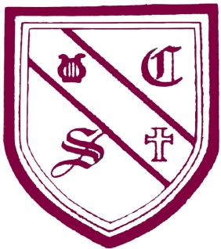St Cecilia’s Catholic Junior School.
PE and sport premium for primary school (2014/15)
Objective | Cost (approx.) | Outcome
- Employ specialist PE teacher and qualified coach to work alongside teachers in lessons to increase their subject knowledge and confidence in PE and sport, e.g. gymnastics, dance, and cross sport skills | Gold Package Sport £6,570.00  Sports trainer £2,000 | The Headtecher and PE co-ordinator will evaluate the following:  - An increase in staff’s subject knowledge and confidence  - Improvement in pupil confidence and attainment  - Progression within each year group
- Providing cover staff to release teachers for professional development in PE and sport. | £280 | - Staff to attend CPD training to ensure quality of teaching and learning in physical education.  - Staff share learning with other staff for maxim impact across the school.
- Staff run after school clubs to enhance pupil’s participation on the school site and at competition level. |  | - Pupils to attend weekly sessions  - Participation at competition level.  - Play friendly matches.  - Increase confidence across sports.  - Positive benefit to pupils health
- Providing pupils who are gifted and talented in sport with expert, intensive coaching and support. |  | - Pupils attend competitions where scouts of professional sports teams are present.  - Pupils have been recruited to local  academies  - Transport
- Provide classroom cover so staff can take pupils to compete at competition level. |  | - Enter tournaments and competitions in a range of sporting activities.
- Affiliation fees for LDCSA | £105 | - Payment for entering competitions in a range of sporting activities.
- Purchasing specialist equipment and teaching resources to develop resources to develop PE and Sport. | £322.91 | - Purchase equipment e.g. replenish basketball, footballs etc.  - New experiences in rugby and netball.

PE Funding 2014/15 | £9,110
Expenditure | £9,277.91
Remaining | -£167.91

