Activities to Support Transition
By Steph Smout
- Making friends. Draw or write about what makes the perfect friend. The children could use a gingerbread man shape or draw around their bodies. Examples might include being friendly, a good listener, being kind, making me laugh, having similar interests. Children consider how they are like this. Children note three interesting things that they could share about themselves when they start their new school. Alternatively, during circle time children could name positive qualities about each other. Focus – notice positive qualities about self and increase self-esteem about making new friends.

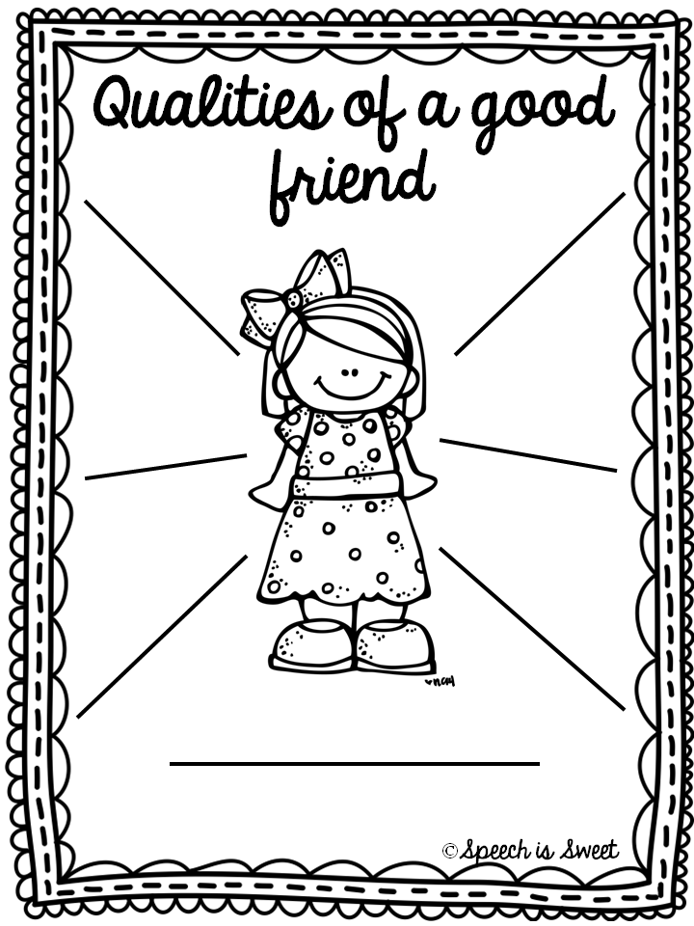

- Letter to future self – advice about what you will look forward to and what you will achieve. This could include subjects you will enjoy the most, things you are most looking forward to, worries about secondary school, what you will miss about primary school, advice to your future self, current dreams and ambitions. The focus of this is to build a growth mind-set and set positive goals. 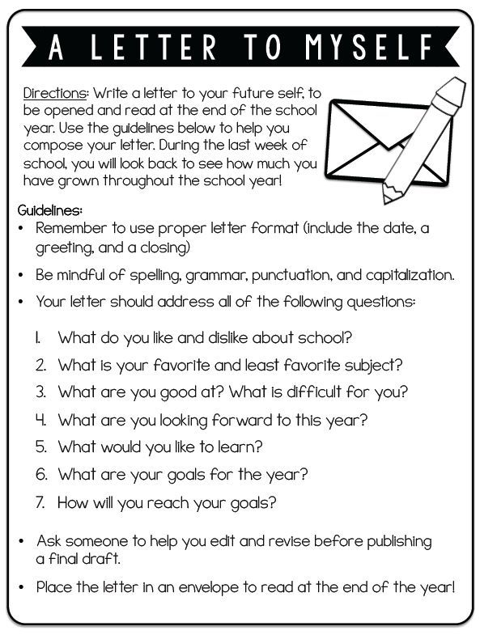

- My First Day at School Storyboard – children draw out cartoon style what their first day of school will look like. The focus of this is to gain an insight into the children’s views and create discussion. This could include problem solving, help to create a positive outlook or reflect on hopes for first day.

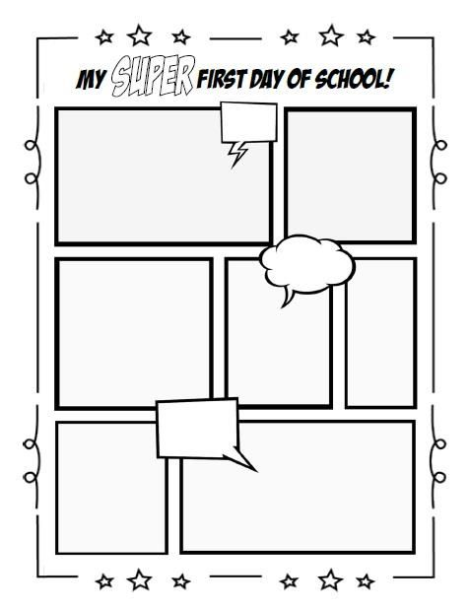

- Using Lego to create ideal classroom. Whilst this would not apply to all children, it can be useful in understanding what helps the child to learn in the classroom, particularly with children with additional learning needs, including what additional strategies they might need to settle.
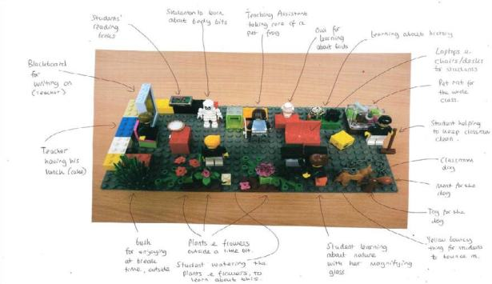

- Role-playing situations of the new school (with Year 2 children this could also be done with puppets). Children could write down situations that are worrying them or the teacher could create problems to which children find solutions. Examples might include getting lost, having lunch, forgetting equipment, getting a homework you don’t understand. The focus is finding different solutions, including people who might be able to help you.

