Activities to Support Anxiety
By Steph Smout Play Therapist
- Make a worry jar out of a container with a screw top lid e.g. empty hot chocolate container. This can be decorated in any way the child wants. There are two ways that this can be used: the child can either speak the worry into the jar, or can write it down, placing it in the jar to be discussed with a grown up at an agreed time. The focus for this activity is naming the worry and sharing it if the child feels able to.
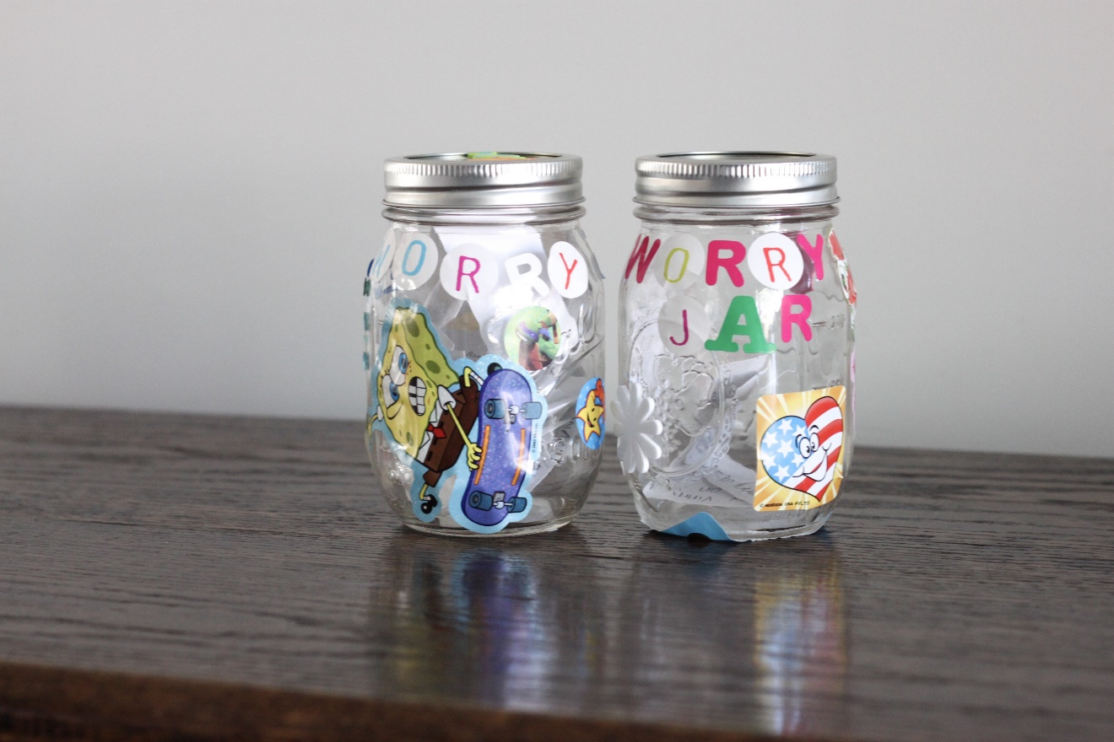
- Blowing worry bubbles – in this activity you blow bubbles, focusing on the long outbreath, as this has a calming effect on the body. You imagine blowing your worries into the bubbles and either popping them or watching them as they float away.

- Worry tree creative visualisation / safe place visualisation. After the child has listened to the visualisation, they might draw the worry tree or safe place. The point of this is to embed the image of safety / being able to cope in their subconscious (see attached sheet for this visualisation script).
- Draw around our bodies or use an outline of a body on A4 paper. Draw where we feel worries in our bodies, giving them a colour. The children might even give their worry a name, e.g. Mr Worrywart / any other name that the child likes or finds funny. The point of this is so they see it as separate from themselves and this can feel less overwhelming. Use post it notes to stick on the picture people who can help with our worries and what makes us feel worried. The focus of this is to develop self-awareness of where we feel anxiety in our body and identifying people who can help.
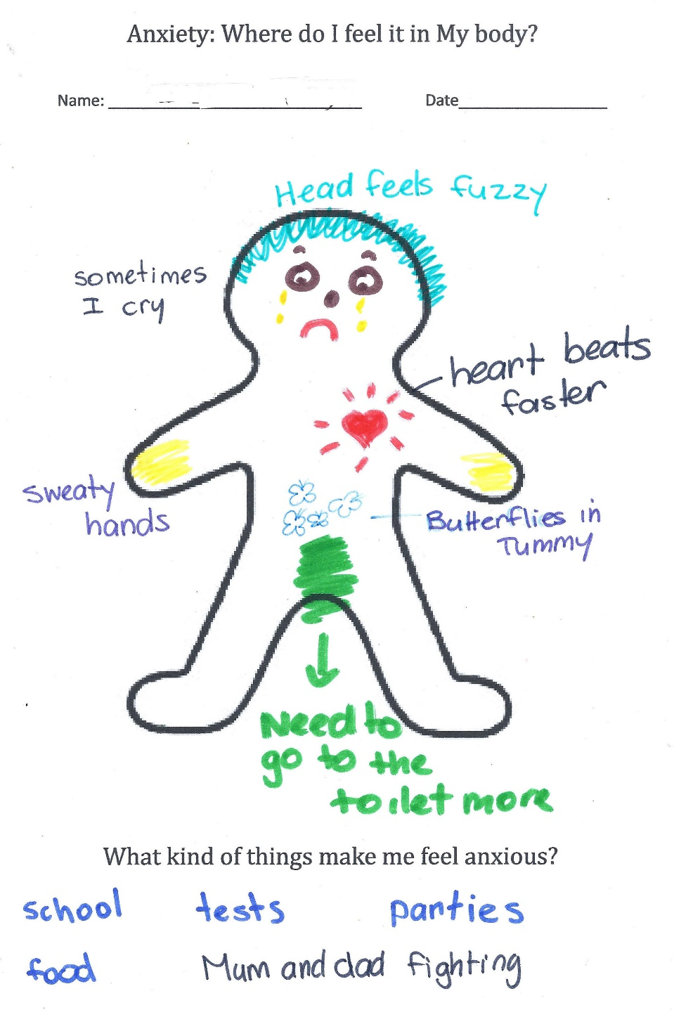

- Anxiety thermometer – This can be used to track throughout the day what children find difficult or challenging at school. This might include discussions such as how ‘hot’ your anxiety thermometer gets at different times of day, with social interactions, particular lessons or activities and the physical environment to give an understanding of triggers. The child can them be involved in discussions about what might help to bring their ‘anxiety heat’ down, such as using breathing activities to calm the body, listening to calming music, squeezing a stress ball. The focus of this is to identify anxiety triggers throughout the day and self-awareness of individualised strategies to help.
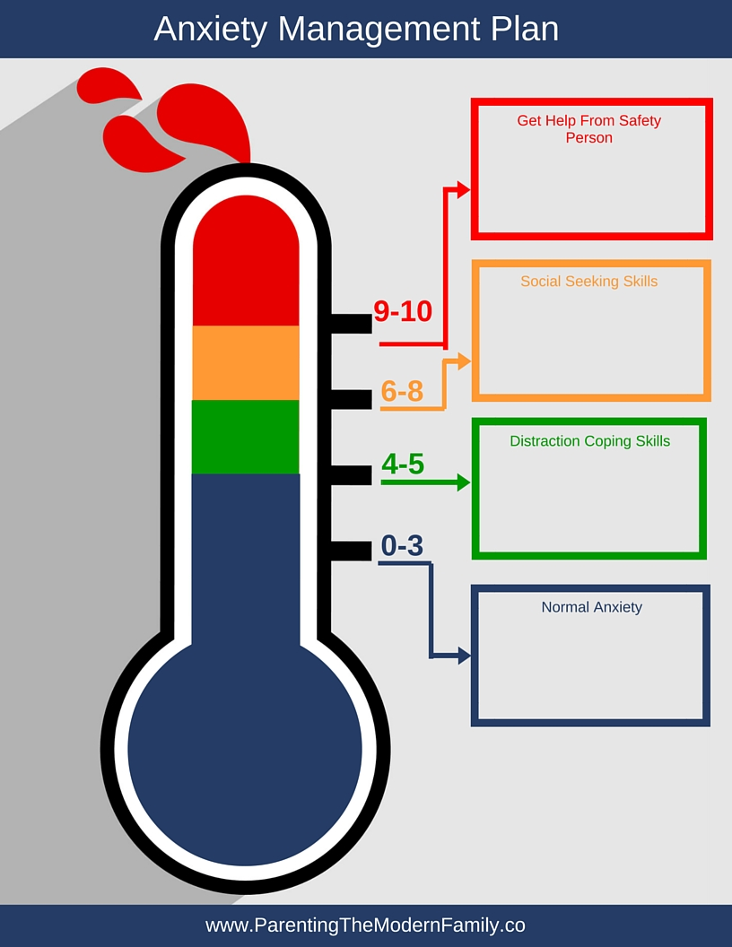

- My Mindful Hand – children draw around their hand and write in their palm a positive experience that they have had. On each finger, they write something they remember about the senses (sight, sound, smell, touch, taste) that they remember about this. In times of anxiety, this can be used to ground the child in making them feel safe with a sense of inner peace. An alternative to this activity is to name 5 things in the current environment you can see, 4 things you can hear, 3 things you can touch, 2 things you can smell and 1 thing you can taste. The point of the latter activity is to bring the child into the present moment - this could be used if they are emotionally heightened.


