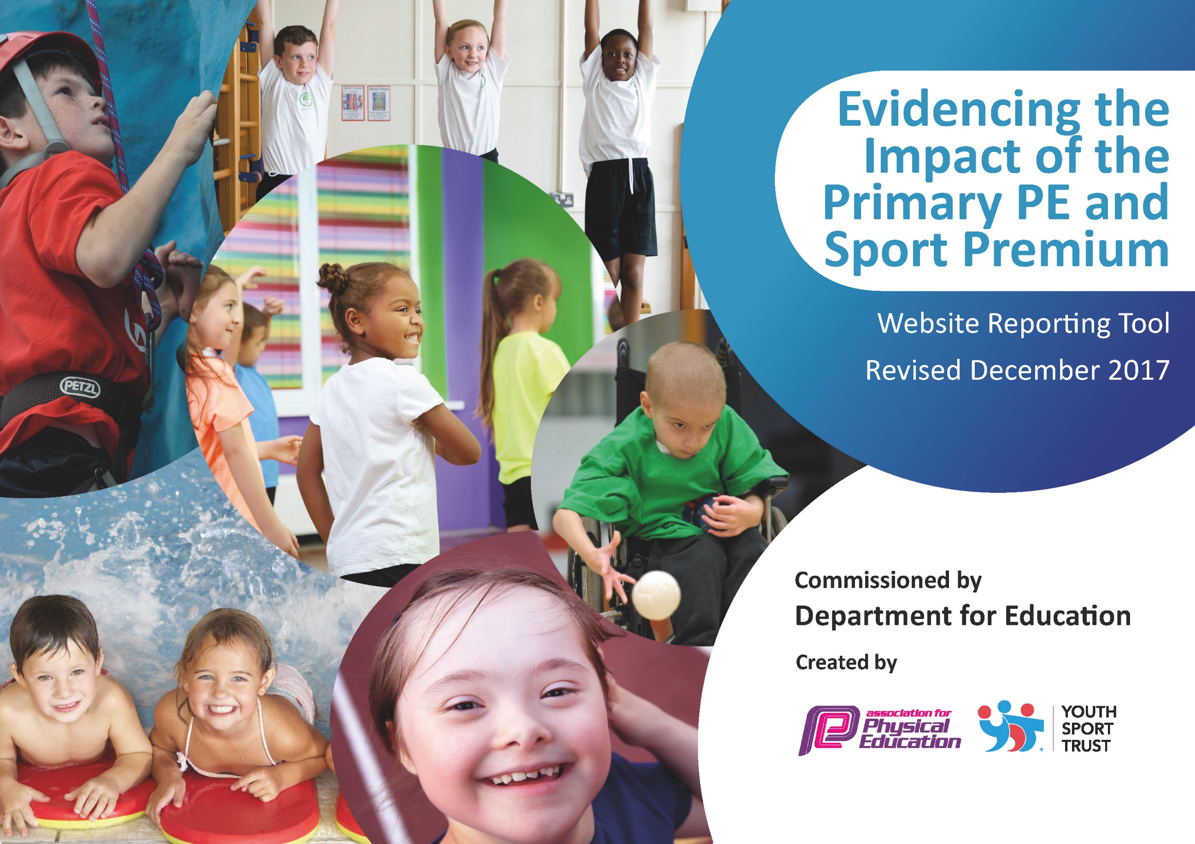

Schools must use the funding to make additional and sustainable improvements to the quality of PE and sport they offer. This means that you should use the Primary PE and Sport Premium to:

- develop or add to the PE and sport activities that your school already offers
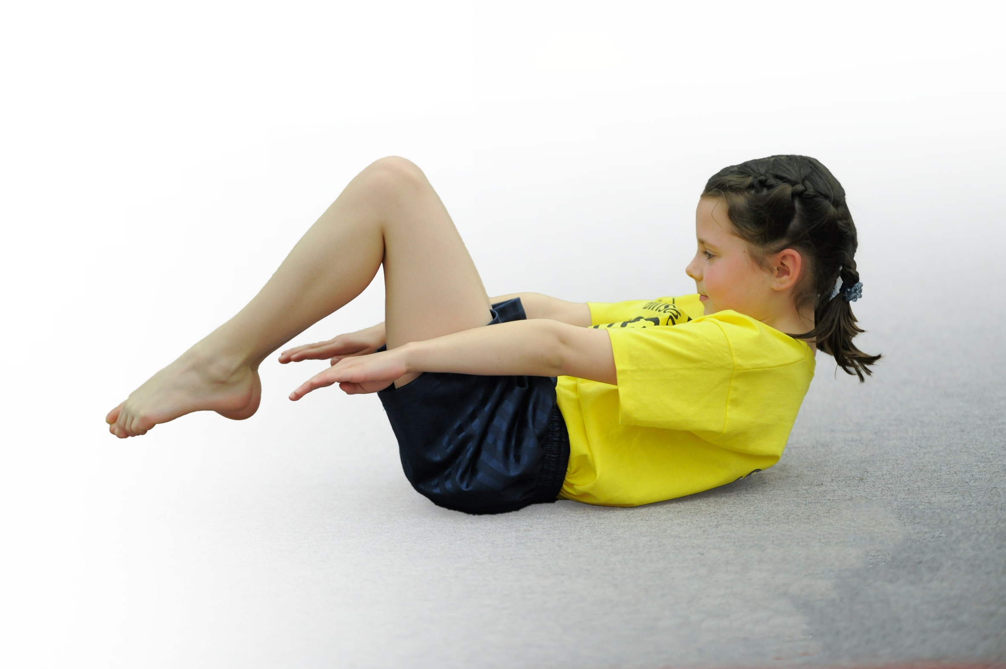
- build capacity and capability within the school to ensure that improvements made now will benefit pupils joining the school in future years

Please visit gov.uk for the revised DfE guidance including the 5 key indicators across which schools should demonstrate an improvement. This document will help you to review your provision and to report your spend. DfE encourages schools to use this template as an effective way of meeting the reporting requirements of the Primary PE and Sport Premium.

We recommend you start by reflecting on the impact of current provision and reviewing the previous spend.
Under the Ofsted Schools Inspection Framework, inspectors will assess how effectively leaders use
the Primary PE and Sport Premium and measure its impact on outcomes for pupils, and how effectively governors hold them to account
for this.

Schools are required to publish details of how they spend this funding as well as on the impact it has on pupils’ PE
and sport participation and attainment.
We recommend regularly updating the table and
publishing it on your website as evidence
of your ongoing review into how you are using the money
to secure maximum, sustainable impact. To see an example of how to complete the table please click HERE.

Support for review and reflection - considering the 5 key indicators from DfE, what development needs are a priority for your setting and your students now and why? Use the space below to reflect on previous spend, identify current need and priorities for the future.

Key achievements to date: | Areas for further improvement and baseline evidence of need:
Silver games mark achieved  Monitoring showed that appropriate amount of PE was taking place  High quality PE sessions observed through drop-in sessions with coach. | Increase the amount of SEND children taking part in sports and promote lesser known sports to enable the achievement of further kitemarks  Monitoring now needs to focus on the PE topics taught and the ensuring the high quality of all PE sessions – staff surveys, pupil surveys to find the gaps. Use monitoring to re-organise the curriculum map to ensure equal access to ALL areas of PE and that the quality of all PE sessions becomes more equal.  Improve the resourcing and staff knowledge of some areas of PE (highlighted by monitoring) to ensure that the quality of PE sessions becomes more equal.

Meeting national curriculum requirements for swimming and water safety | Please complete all of the below*:
What percentage of your current Year 6 cohort swim competently, confidently and proficiently over a distance of at least 25 metres? | 85.7%
What percentage of your current Year 6 cohort use a range of strokes effectively [for example, front crawl, backstroke and breaststroke]? | 67.8%
What percentage of your current Year 6 cohort perform safe self-rescue in different water-based situations? | 100%
Schools can choose to use the Primary PE and Sport Premium to provide additional provision for swimming but this must be for activity over and above the national curriculum requirements. Have you used it in this way? | No
*Schools may wish to provide this information in April, just before the publication deadline.

Action Plan and Budget Tracking
Capture your intended annual spend against the 5 key indicators. Clarify the success criteria and evidence of impact that you intend to measure to evaluate for students today and for the future.

Academic Year: 2017/18 | Total fund allocated: £ 14460 | Date Updated: April/May 2018
Key indicator 1: The engagement of all pupils in regular physical activity – Chief Medical Officer guidelines recommend that primary school children undertake at least 30 minutes of physical activity a day in school |  |  |  | Percentage of total allocation:
 |  |  |  | 46.49%
School focus with clarity on intended impact on pupils: | Actions to achieve: | Funding allocated: | Evidence and impact: | Sustainability and suggested next steps:
Maintain the high-quality provision of PE sessions run by the PE coach – ensuring progression of skills for students.  Purchasing of playground equipment to engage children in physical activity during playtimes. A variety of different equipment should be present to allow students to engage in sports other than football.  Purchasing of swimming and PE kits to remove barriers to learning for some children | Utilisation of sports coach for PE lessons, competition training and the running of the daily mile on Fun Fit Fridays  Purchase and installation of gym equipment. Purchase and utlisation of a variety of equipment- promoting basketball, rugby, dodgeball, circus skills  Pastoral staff to ensure the purchasing of PE kits. These will be used by children in need of them to allow them to participate in PE/swimming sessions. | £4500  £2173  £50  Total: £6,723 | Drop-ins have shown engagement and engagement of children in PE sessions, training sessions and daily mile. Children report enjoyment of these sessions.  Children are seen to be enjoying a variety of different sports during their playtimes. Drop ins have shown children taking part in basketball, football, rugby, tennis, skipping  Several children have used the PE kits this year, allowing them to take part in PE sessions which would otherwise been missed. This children include PP children and EAL children, who would otherwise not have had access to appropriate clothing for PE | Maintain provision by sports coach. Embed assessment criteria and accountability to measure progress during sessions by PE coach and class teachers.  Installation of gym equipment to take place before the next academic year. Play leaders role to be extended next year to support children in playing of sports further next academic year.  Some kits have gone missing and need to be replaced.
Key indicator 2: The profile of PE and sport being raised across the school as a tool for whole school improvement |  |  |  | Percentage of total allocation:
 |  |  |  | 7.4%
School focus with clarity on intended impact on pupils: | Actions to achieve: | Funding allocated: | Evidence and impact: | Sustainability and suggested next steps:
Visit by (and promotion of) team GB triple jumper Naomi Ogbeta – children developed knowledge about her sport and the life of an athlete, as well as taking part in circuit training run by her and her team.  Whole school Sports and Health Week – children to be engaged in a variety of different physical activities during this week – experiencing new activities- with the focus being on enjoyment and healthy lifestyles.  Purchase of prizes/rewards/certificates to celebrate sporting achievements and promote enjoyment and profile of PE across the whole school – foster a sense of pride for those children who have done well! | Children to take part in circuit training and Q&A with Naomi. Promoted on school newsletter and school twitter.  Sports week (and Sports Day) to take place at the end of June. Arranged for different sports/physical activities to take place (world cup football, athletics, yoga, circus skills)  Purchase prizes, medals, and use these to celebrate achievements in Sports Day and Sports Week | £0  £350  £396  £318  Total: £1064 | Several months on, children still remember the visit and can recall what they learnt about the triple jump.  Children report a “buzz” about sports during sports week and will hopefully remember the week for years to come. There should be an increase in the numbers of children taking part in activities available at break times (e.g circus skills and racing) observed by staff members  Children are rewarded for their sporting talents and knowledge of healthy lifestyles– promoting a “buzz” and awareness of the importance of healthy minds and healthy bodies – evidenced by children’s work. | Continue to celebrate achievements by Naomi Ogbeta in the school. Research other athletes or sports to could visit the school in the next academic year.  Continue to have a “Sports Week” to promote sports each year, with different activities where available, to allow for the exposure and introduction of different sports. Where possible, provide children with information for clubs and groups they can attend to further develop their skills.  Continue to promote and celebrate achievements of all sports and physical activities, including publishing a “Sports Star of the Week” for each class on the school newsletter.

Key indicator 3: Increased confidence, knowledge and skills of all staff in teaching PE and sport |  |  |  | Percentage of total allocation:
 |  |  |  | 16.32%
School focus with clarity on intended  impact on pupils: | Actions to achieve: | Funding  allocated: | Evidence and impact: | Sustainability and suggested  next steps:
LSSP member ship allowing PE lead attending workshops and training to be updated on National Standards and expectations. This knowledge is then used to improve the quality of PE experiences for children in the school and allows children to take part in competitions run by LSSP.  iMoves curriculum programme bought – provides lesson plans and videos to demonstrate the standards expected in the new curriculum. This will increase the knowledge, confidence and skills staff, resulting in higher quality provision for pupils. | ED to attend subject leader briefings and have 1:1 session on PE premium funding and expectations.  iMoves programme bought.  ED to roll this out to staff, showing how to use this and how to use this in conjunction with school planning. | £1495.00  £310  £555  Total: £2360 | Increased knowledge and confidence for subject leader. The knowledge gained from these sessions was then used to develop PE action plan and improve provision for pupils  Increased confidence from staff when delivering lessons from curriculum (especially in those areas which were found to have lower confidence, e.g gym, dance). | Subject lead to continue to attend training and briefing sessions to remain up to date with current expectations and standards.  Staff survey to discover confidence etc after utilization of new program.
Key indicator 4: Broader experience of a range of sports and activities offered to all pupils |  |  |  | Percentage of total allocation:
 |  |  |  | 27.75%
School focus with clarity on intended  impact on pupils: | Actions to achieve: | Funding  allocated: | Evidence and impact: | Sustainability and suggested  next steps:
To provide children with a range of different sports and activities, many of which they will have had limited access to before. (This was also covered during Sports Week, as part of KI2, but the funding listed here is separate from that used for Sports Week).  Expand the PE cupboard to allow room and storage for a greater range of resources. | At different points of the year, allow children to experience different or new activities, through visiting professionals or new resources  Circus skills  Highland Games (SEND focus)  Dance from different cultures  Futsall  Triple Jump  Caretaker to increase the storage capacity to allow for new resources. | £396  £1890  £1575  £152  Total: £4013 | Circus Skills workshops taken place and equipment bought. Use has been timetabled on the yard and children now have access to new equipment.  A team of 8 SEND pupils took part in the Highland games and thoroughly enjoyed themselves. All years benefitted from learning dance from different cultures, e.g Cheerleading, Bollywood, Street Dance, to a greater extent than in previous years and in line with new curriculum expectations. A team of children also took part in the school’s first Futsal tournament. Triple Jump promoted by Naomi Ogbeta.  Cupboard capacity increased, allowing the children access to a greater number and variety of resources. | Utilise the playleaders to help younger children to develop balance, coordination etc using circus equipment at playtimes.  Continue to take part in different types of dance and sporting competitions. Futsall and Highland game participation to repeat next year, whilst continuing to expand the competition calender.  Once PE cupboard has been renovated, purchase equipment to allow involvement in other sporting activities.
Key indicator 5: Increased participation in competitive sport |  |  |  | Percentage of total allocation:
 |  |  |  | 2.7%
School focus with clarity on intended  impact on pupils: | Actions to achieve: | Funding  allocated: | Evidence and impact: | Sustainability and suggested  next steps:
Provision of School Minibus to ensure that all children have access to competitive sport, removing barriers which could stop potential competitors.  Provision of kits to allow children to compete, without the barrier of lack of sports clothing etc  Affiliation to LDCSA | School minibus used to transport children to a variety of different competitions  Purchase replacement parts of kit as and when necessary  Subs paid, meetings and competitions attended. | £260  £29.05  £110 | Mini-bus used to transport children to:  Futsal  Dance competition  Swimming City Finals  Football  Highland Games  Quicksticks  Children wearing kits for competitions  ED attended meetings, children attending LDCSA atheletics | Continue to use school min-bus next year.  Continue to provide kits in future academic years – purchase of school swimming caps, shin pads and goalie gloves to be kept in school.  Revise which competitions to attend next year (check overlap with LSSP)

