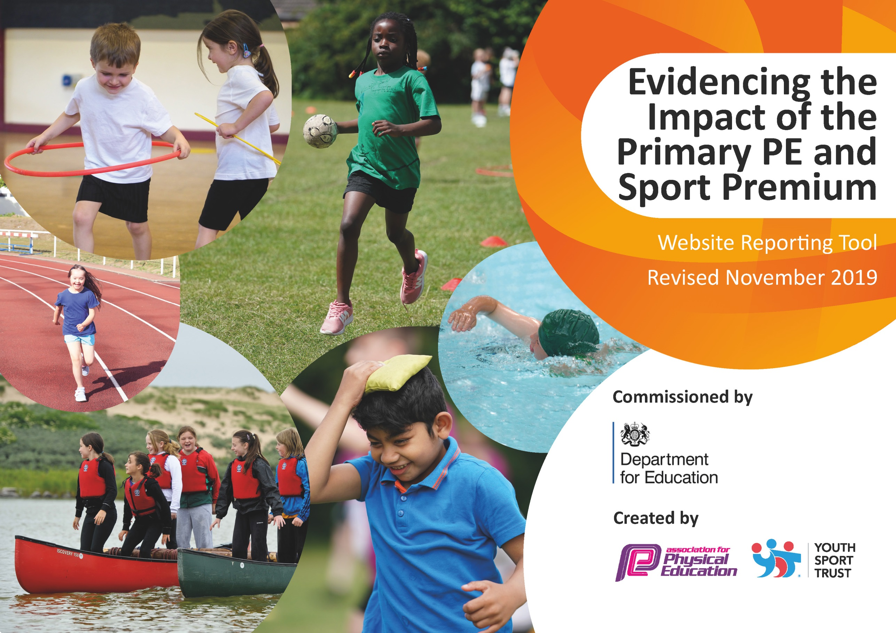
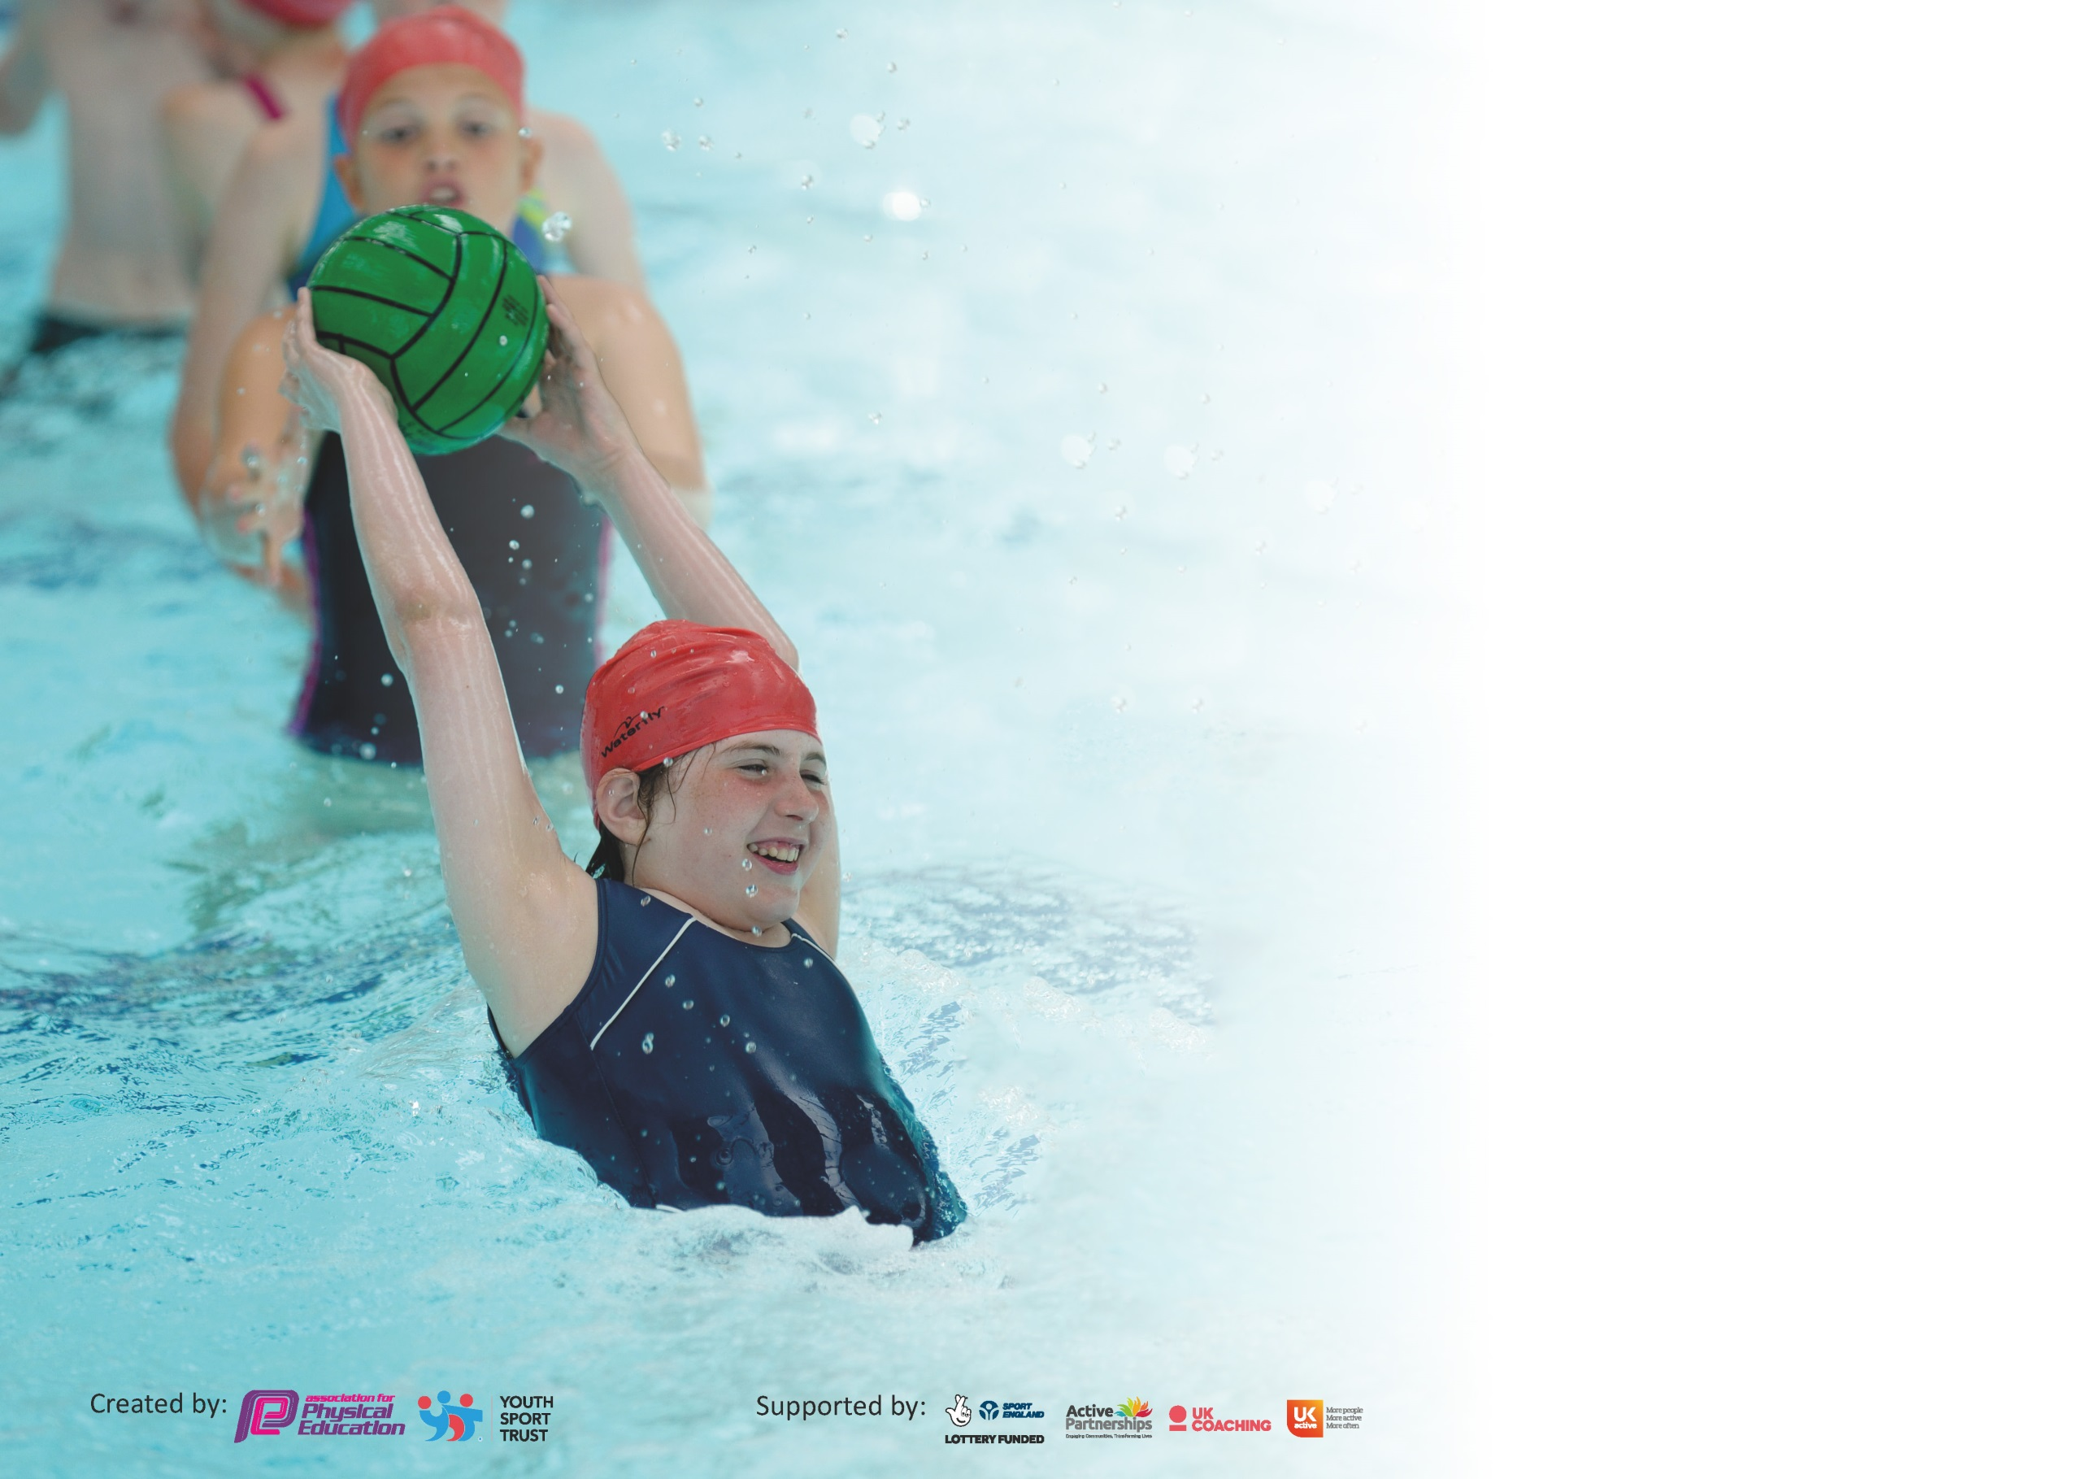

It is important that your grant is used effectively and based on school need. The Education Inspection Framework (Ofsted 2019 p64) makes clear there will be a focus on ‘whether leaders and those responsible for governors all understand their respective roles and perform these in a way that enhances the effectiveness of the school’.

Under the Quality of Education criteria (p41) inspectors consider the extent to which schools can articulate their curriculum (INTENT), construct their curriculum (IMPLEMENTATION) and demonstrate the outcomes which result (IMPACT).

To assist schools with common transferable language this template has been developed to utilise the same three headings which should make your plans easily transferable between working documents.

Schools must use the funding to make additional and sustainable improvements to the quality of Physical Education, School Sport and Physical Activity (PESSPA) they offer. This means that you should
use the Primary PE and Sport Premium to:

- Develop or add to the PESSPA activities that your school already offer
- Build capacity and capability within the school to ensure that improvements made now will benefit pupils joining the school in future years

Please visit gov.uk for the revised DfE guidance including the 5 key indicators across which schools should demonstrate an improvement. This document will help you to review your provision and to report your spend. DfE encourages schools to use this template as an effective way of meeting the reporting requirements of the Primary PE and Sport Premium.

We recommend you start by reflecting on the impact of current provision and reviewing the previous spend.

Schools are required to publish details of how they spend this funding as well as on the impact it has on pupils’ PE and sport participation and attainment by the end of the summer term or by 31st July 2020 at the latest.

We recommend regularly updating the table and publishing it on your website throughout the year. This evidences your ongoing self-evaluation of how you are using the funding to secure maximum, sustainable impact. Final copy must be posted on your website by the end of the academic year and no later than the 31st July 2020. To see an example of how to complete the table please click HERE.

Support for review and reflection - considering the 5 key indicators from DfE, what development needs are a priority for your setting and your pupils now and why? Use the space below to reflect on previous spend and key achievements and areas for development.

Key achievements to date until July 2019: | Areas for further improvement and baseline evidence of need:
Bronze School games mark.  Good use of ‘My Personal Best’ throughout the school. | Increase the amount of SEND children taking part in sports and promote lesser known sports to enable the achievement of further kitemarks  Monitoring now needs to focus on the PE topics taught and the ensuring the high quality of all PE sessions – staff surveys, pupil surveys to find the gaps. Use monitoring to re-organise the curriculum map to ensure equal access to ALL areas of PE and that the quality of all PE sessions becomes more equal.  Improve the resourcing and staff knowledge of some areas of PE (highlighted by monitoring) to ensure that the quality of PE sessions becomes more equal.

Meeting national curriculum requirements for swimming and water safety.
What percentage of your current Year 6 cohort swim competently, confidently and proficiently over a distance of at least 25 metres?  N.B. Even though your pupils may swim in another year please report on their attainment on leaving  primary school at the end of the summer term 2020. | 80%
What percentage of your current Year 6 cohort use a range of strokes effectively [for example, front crawl, backstroke and breaststroke]? | %
What percentage of your current Year 6 cohort perform safe self-rescue in different water-based situations? | 100%
Schools can choose to use the Primary PE and Sport Premium to provide additional provision for swimming but this must be for activity over and above the national curriculum requirements. Have you used it in this way? | No

Action Plan and Budget Tracking
Capture your intended annual spend against the 5 key indicators. Clarify the success criteria and evidence of impact that you intend to measure to evaluate for pupils today and for the future.

Academic Year: 2019/20 | Total fund allocated: £24,080 | Date Updated:
Key indicator 1: The engagement of all pupils in regular physical activity – Chief Medical Officer guidelines recommend that primary school pupils undertake at least 30 minutes of physical activity a day in school |  |  |  | Percentage of total allocation:
 |  |  |  | 55%
Intent | Implementation |  | Impact
Your school focus should be clear what you want the pupils to know and be able to do and about  what they need to learn and to  consolidate through practice: | Make sure your actions to achieve are linked to your intentions: | Funding allocated: | Evidence of impact: what do pupils now know and what can they now do? What has changed?: | Sustainability and suggested next steps:
Maintain the high-quality provision of PE sessions run by the PE coach – ensuring progression of skills for students. | Getset4PE programme  Sports coach | £380  £12,920  £13,300 | Drop-ins have shown engagement and engagement of children in PE sessions and training sessions. Children report enjoyment of these sessions.  The sports coach has been used for focus groups to get the least active children in the school moving. | To continue to use the ‘Getset4PE’ programme for teaching PE.
Key indicator 2: The profile of PESSPA being raised across the school as a tool for whole school improvement |  |  |  | Percentage of total allocation:
 |  |  |  | 3%
Intent | Implementation |  | Impact
Your school focus should be clear what you want the pupils to know and be able to do and about  what they need to learn and to  consolidate through practice: | Make sure your actions to achieve are linked to your intentions: | Funding allocated: | Evidence of impact: what do pupils now know and what can they now do? What has changed?: | Sustainability and suggested next steps:
To invite inspirational sports people to speak to the children about the importance of sports.  Whole school Sports and Health Week – children to be engaged in a variety of different physical activities during this week – experiencing new activities- with the focus being on enjoyment and healthy lifestyles. | Liverpool boxer Callum Smith lead an assembly with all children.  Sports week taken place in the Summer term. Quidditch organisation to come in and teach the children quidditch and host an intra-competition.  Gymnastics company to come in and teach each class gymnastics. | £0  £516  £140  £656 | Several months on children still talk about the assembly and how inspired they were by Callum. | Continue to celebrate Liverpool sports people and try and have others visit the school.

Key indicator 3: Increased confidence, knowledge and skills of all staff in teaching PE and sport |  |  |  | Percentage of total allocation:
 |  |  |  | 14%
Intent | Implementation |  | Impact
Your school focus should be clear | Make sure your actions to | Funding | Evidence of impact: what do | Sustainability and suggested
what you want the pupils to know | achieve are linked to your | allocated: | pupils now know and what | next steps:
and be able to do and about | intentions: |  | can they now do? What has
what they need to learn and to |  |  | Changed?:
consolidate through practice:
LSSP member ship allowing PE lead attending workshops and training to be updated on National Standards and expectations. This knowledge is then used to improve the quality of PE experiences for children in the school and allows children to take part in competitions run by LSSP. | LMC to attend subject leader briefings and have 1:1 session on PE premium funding and expectations. | £3365 | Increased knowledge and confidence for subject leader. The knowledge gained from these sessions was then used to develop PE action plan and improve provision for pupils | Subject lead to continue to attend training and briefing sessions to remain up to date with current expectations and standards.
Key indicator 4: Broader experience of a range of sports and activities offered to all pupils |  |  |  | Percentage of total allocation:
 |  |  |  | 5%
Intent | Implementation |  | Impact
Your school focus should be clear | Make sure your actions to | Funding | Evidence of impact: what do | Sustainability and suggested
what you want the pupils to know | achieve are linked to your | allocated: | pupils now know and what | next steps:
and be able to do and about | intentions: |  | can they now do? What has
what they need to learn and to |  |  | changed?:
consolidate through practice:
Additional achievements:  To provide children with a range of different sports and activities, many of which they will have had limited access to before. (This was also covered during Sports Week, as part of KI2, but the funding listed here is separate from that used for Sports Week). | Strike dance to come in and teach quality dance lessons to all year groups for 6 weeks. | £1200 | Children participated in quality dance lessons. Children were engaged and gave positive feedback. Some children then went to joining the dance after school club as they enjoyed the lessons. | To use professional coaches to give the children qualitive lessons in different sports.

Key indicator 5: Increased participation in competitive sport |  |  |  | Percentage of total allocation:
 |  |  |  | 2%
Intent | Implementation |  | Impact
Your school focus should be clear | Make sure your actions to | Funding | Evidence of impact: what do | Sustainability and suggested
what you want the pupils to know | achieve are linked to your | allocated: | pupils now know and what | next steps:
and be able to do and about | intentions: |  | can they now do? What has
what they need to learn and to |  |  | changed?:
consolidate through practice:
Provision of kits to allow children to compete, without the barrier of lack of sports clothing etc  Provision of School Minibus to ensure that all children have access to competitive sport, removing barriers which could stop potential competitors.  Dance costumes bought for dance troupes to enter the LSSP dance competition. | New kits bought for children who don’t have them (PP).  2 spare kits bought for each class so children don’t have to miss out on lessons.  Mini bus used to take children to and from sporting events.  Children’s dance costumes bought for them to wear during the competitions. | £30  £60  £260  £100  £420 | All children have been able to join in during PE lessons.  We have been able to take children to competitions against other schools.  Children have been able enter competitions and earn points for how they are presented as a group. | To ensure each class has a spare kit and also that PP children have their own kit.  We have raised the drive for competitive sports within the schools so therefore next year we can enter more competitions.  Use the costumes again for other competitions.

Signed off by
Head Teacher:
Date:
Subject Leader:
Date:
Governor:
Date:

