
St. Cecilia’s R.C Junior School
Relationship, Sex and Health Education Policy (RSHE)
2021

Chair of Governors | Mr L Foggarty
Headteacher | Mrs P Agate
Date adopted: September 2021 | Review Date: September 2022

St. Cecilia’s Junior School Mission Statement

Rooted in gospel values St Cecilia’s Catholic School Community lives together, learns together, and loves together.
Aims

Live :
We strive to be a community where everyone feels safe, secure and cared for, where all are respected and loved.

Learn :
We aim to provide an environment full of creativity, where talents grow and uniqueness is celebrated. We encourage co-operation and develop new experiences through exciting teaching methods.

Love :
We aim to create a school family where each person can experience the love of God. We seek to promote gospel values modelling Christian principles throughout our school community.

LOVE ONE ANOTHER, AS I HAVE LOVED YOU

Our Core Values

Friendship and Responsibility - High expectations for all in learning and behaviour.
Respect and Tolerance - Relationships based on equality, trust and sincerity.
Integrity and Honesty- Decisions and actions based on Christian values- ‘What would Jesus do?’
Service and Democracy - Recognising our Christian duty and the importance of pupil voice.
Forgiveness and Peace - Always being willing to say sorry and rebuild a broken relationship.
Creativity and Compassion – Celebrating gifts, talents, skills and diversity.
Courage and Humility – Personal drive coupled with the ability to be humble in nature.
Generosity and Thankfulness - Giving and grateful hearts.

Rationale
‘I HAVE COME THAT YOU MIGHT HAVE LIFE AND HAVE IT TO THE FULL’
(Jn.10.10)
We are involved in Relationship, Sex and Education (RSE) precisely because of our Christian beliefs about God and about the human person. The belief in the unique dignity of the human person made in the image and likeness of God underpins the approach to all education in a Catholic school. Our approach to RSE therefore is rooted in the Catholic Church’s teaching of the human person and presented in a positive framework of Christian ideals.
At the heart of the Christian life is the Trinity; Father, Son and Spirit in communion, united in loving relationship and embracing all people and all creation. As a consequence of the Christian belief that we are made in the image and likeness of God, gender and sexuality are seen as God’s gift, reflect God’s beauty, and share in the divine creativity. RSE, therefore, will be placed firmly within the context of relationship as it is there that sexuality grows and develops.
Following the guidance of the Bishops of England and Wales and as advocated by the DFE (and the Welsh Assembly Government) RSE will be firmly embedded in the PSHE/RSHE framework as it is concerned with nurturing human wholeness and integral to the physical, spiritual, emotional, moral, social and intellectual development of pupils. It is centred on Christ’s vision of being human as good news and will be positive and prudent, showing the potential for development, while enabling the dangers and risks involved to be understood and appreciated.
All Relationship, Sex and Health Education RSHE will be in accordance with the Church’s moral teaching. It will emphasise the central importance of marriage and the family whilst acknowledging that all pupils have a fundamental right to have their life respected whatever household they come from. It will also prepare pupils for life in modern Britain.

Aim
St. Cecilia’s Catholic Junior School aims to provide a suitable programme that follows the statutory need to include RSHE into their curriculum from September 2020 which meets the ethos of its Catholic mission and identity.
The purpose of this Relationship, Sex and Health Education (RSHE) policy is to set out the ways in which the school’s provision supports pupils through their spiritual, moral, social, emotional and physical development, and prepares them for the opportunities, responsibilities and experiences of life growing up in today’s world.
Our School’s mission embraces the spiritual, physical, intellectual, emotional, moral and social development of children and young people, and through an agreed approach to Relationship and Sex Education (RSE) using the recommended resource ‘Journey In’ Love 2020 we believe that we can promote the development of the whole child, so that children can grow in wisdom and stature, understanding both the emotional, social and physical aspects of growing spiritually, as well as moral aspects of relationships within a context of a Christian vision for the purpose of life.
The other aspects of the Statutory curriculum intent will be met by Journey in Love (See appendices at end of document which incorporates Come and See, DFE Statutory Relationships and Statutory Science)
The Purpose
The aims of Relationship, Sex and Health Education (RSHE) at St. Cecilia’s Junior School are to:

- Provide a framework in which sensitive discussions can take place.
- Help pupils develop feelings of dignity, self-worth, self-respect, confidence and empathy.
- Prepare pupils for puberty, and give them an understanding of sexual development and the importance of health and hygiene.
- Create a positive culture around issues of sexuality and relationships.
- Teach pupils the correct vocabulary to describe themselves and their bodies.

Statutory Requirements
At St. Cecilia’s Junior School we must provide Relationships Education to all pupils as per section 34 of the Children and Social work act 2017.

In teaching Relationship and Sex Education, we must have regard to Catholic Education Service guidance issued by the Bishops Conference of England and Wales 2017.

This is statutory guidance from the Department for Education issued under Section 80A of the Education Act 2002 and section 403 of the Education Act 1996 Appendix A

This is statutory guidance from the Department for Education Equality Act 2010.

Policy Development
This policy has been developed in consultation with staff, pupils and parents. The consultation and policy development process involved the following steps:

- Review – C. Patterson (RE Coordinator)
P. Agate (Head teacher)
S. Hurst (Deputy Head teacher / Curriculum lead)
J. Coleman (Learning Mentor)
Liverpool Archdiocese Christian Education Department
School Improvement Liverpool

- Staff consultation – all school staff were given the opportunity to look at the policy and make recommendations.

- Parent/stakeholder consultation – parents and any interested parties including the Diocesan adviser/schools’ officers were invited to attend meetings about the policy.

- Pupil consultation – we investigated what exactly pupils want from their Relationship Sex and Health Education lessons. School council were consulted on the content of lessons and guidance.

- Ratification – once amendments were made, the policy was shared with governors and ratified.

Definition

Relationship, Sex and Health Education involves a combination of sharing information, and exploring issues underpinned by our Catholic values.

Relationship Sex and Health Education is about the emotional, social and cultural development of pupils, and involves learning about personal relationships, sexual health, sexuality, healthy lifestyles, diversity and personal identity.

Curriculum

We have developed our curriculum with recommendations from the Archdiocesan Education Department to ensure that they meet with Catholic Church teaching.

After consultation with parents Relationship Sex Education will be covered using the Archdiocesan recommended resource ‘Journey In Love’ 2020 this includes *sexual intercourse at Year 6. (See right of withdrawal)

We have considered the age, stage and feelings of pupils and have consulted with parents and staff to ensure we are offering a quality curriculum which is adequately catered to meet their needs.

We have adapted the ‘You, Me P.S.H.E’ scheme, sanctioned by School Improvement Liverpool P.S.H.E department, and this has been adjusted to omit lessons with RSE content already covered by the ‘Journey In Love’ Scheme. We have also introduced ‘No Outsiders at Our School’ as a scheme to deal with issues around equality.
If pupils ask questions outside the scope of our curriculum, teachers will respond in an appropriate manner, so they are fully informed and do not seek answers online.

Delivery of Relationship, Sex and Health Education (RSHE)

Relationship and Sex Education (RSE) is taught both discrete and within the Personal, Social and Health Education (PSHE) curriculum lessons. Some aspects of the RSHE curriculum may be touched upon in other lessons as it shares links with Religious Education, Science and Physical Education.

Our RSHE will ensure that content is relevant to the age, experience and maturity of pupils.
The new statutory guidance for Relationships education focuses on teaching the fundamental building blocks and characteristics of positive relationships including:

- Families and people who care for me.
- Caring friendships.
- Respectful relationships.
- Online relationships.
- Being safe.
These areas of learning are taught within the context of ‘family life’ and could include married or single parent families, same sex parents, families headed by grandparents, adoptive parents, foster parents/carers amongst other structures, along with reflecting sensitively that some children may have a support structure around them (for example: looked after children or young carers).

As a school, we promote equality of opportunity and foster good relations. Our school environment uniformly applies values of inclusion and respect to all pupils and their families. All staff are proactive in promoting positive relationships and receive regular training.

Equal Opportunities

All pupils have access to the RSHE curriculum. Where pupils have specific educational needs, arrangements for support from outside agencies and support staff are made to ensure these pupils have an appropriate, differentiated curriculum.

Roles and Responsibility

The Governing Body
The governing body will approve the RSHE policy and hold the headteacher to account for its implementation.
The headteacher
The headteacher is responsible for ensuring that RSHE is taught consistently across the school and for managing requests to withdraw pupils from the non-statutory element of Relationship and Sex Education in Year 6* (see right of withdrawal)
Staff
Staff do not have the right to opt out of teaching RSHE as this forms part of the Teaching Standards. Any staff who have concerns about teaching RSHE are encouraged to discuss this with the headteacher.

Staff are responsible for:
- Delivering RSHE in a sensitive way.
- Modelling positive attitudes to RSHE.
- Monitoring progress.
- Responding to the needs of individual pupils.
- Responding appropriately to pupils whose parents wish them to be withdrawn from the non-statutory components of RSE.

Pupils
Pupils are expected to engage fully in RSHE and, when discussing issues related to RSHE, treat others with respect and sensitivity.

Parents’ right to withdraw

Parents have the right to withdraw their children from the non-statutory sexual intercourse component of sex education in Year 6.
Requests for withdrawal should be made in writing and addressed to the headteacher. The headteacher will discuss the request with parents and take appropriate action.
Alternative work will be given to pupils who are withdrawn from RSE.
Parents do not have the right to withdraw their children from Relationships Education 2020.

Monitoring arrangements

The delivery of RSHE is monitored by C. Patterson (R.S.H.E/ P.S.H.E/ R.E co-ordinator) through learning walks, staff and pupil consultations, planning and work scrutinies and questionnaires.

Pupils’ development in RSE is monitored by class teachers as part of our internal assessment systems.

This policy will be agreed annually by the governors and reviewed every three years.
Resources
The PSHE Association www.pshe-association.org.uk
The Underwear PANTS Rule www.nspcc.org.uk
Journey In Love https://www.mccrimmons.com/shop/books/a-journey-in-love-volume-1--book/

No Outsiders in Our School https://no-outsiders.com/

Cafod https://cafod.org.uk/

CEOP – National Crime Agency Command www.thinkuknow.co.uk

St. Cecilia’s SMSC Gridmaker

Appendix 1

St. Cecilia’s Junior School Curriculum map

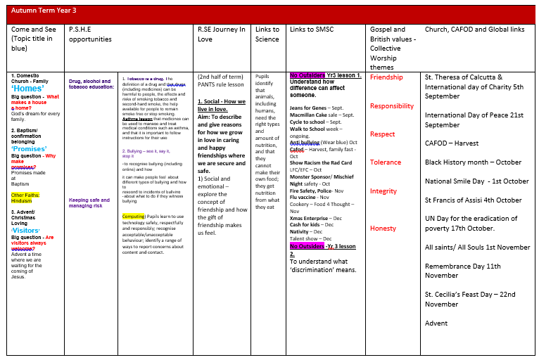

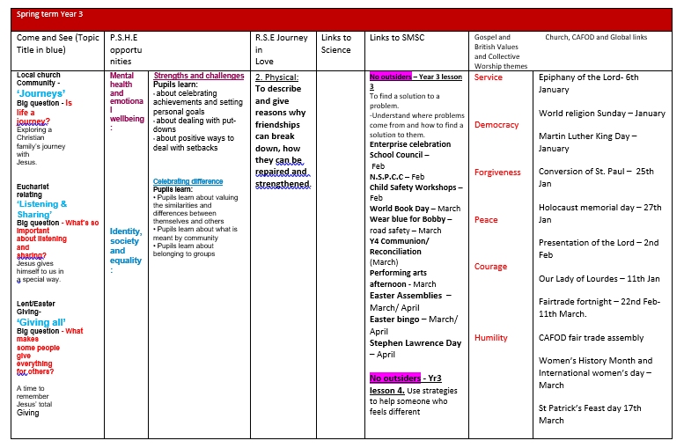

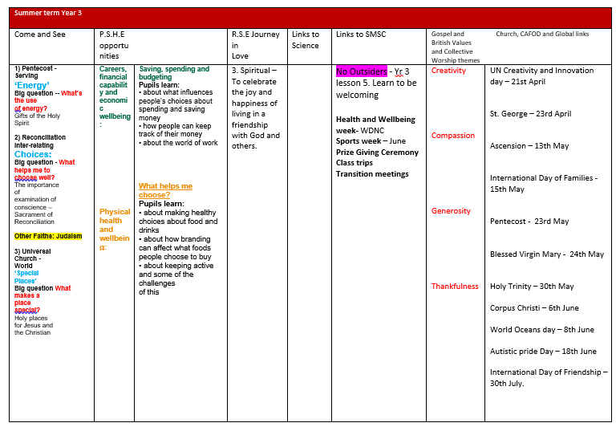

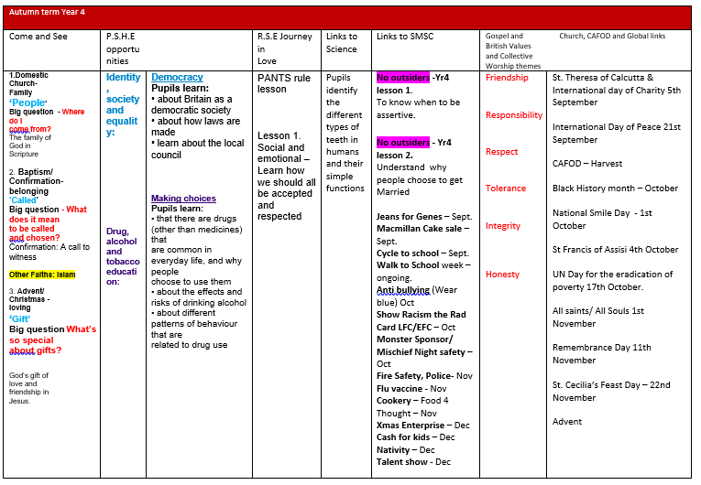

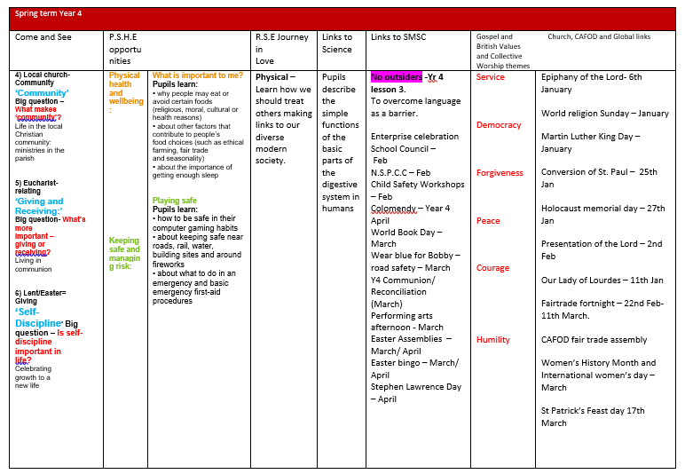

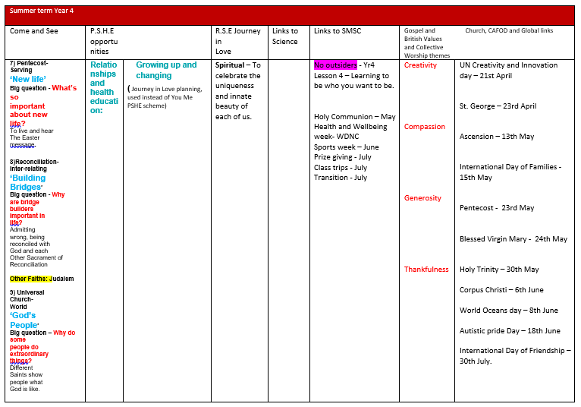

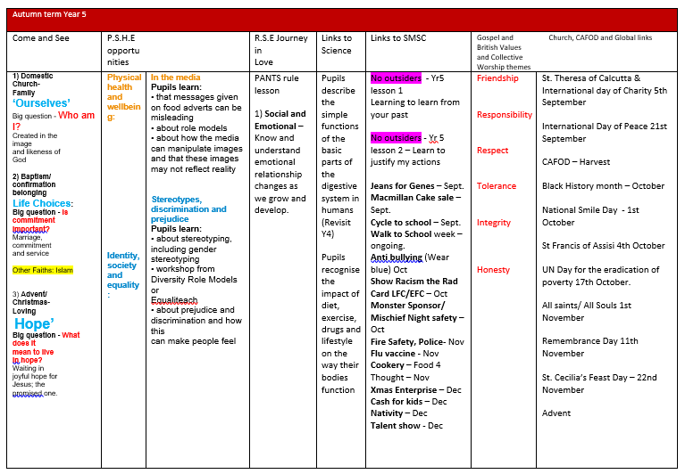

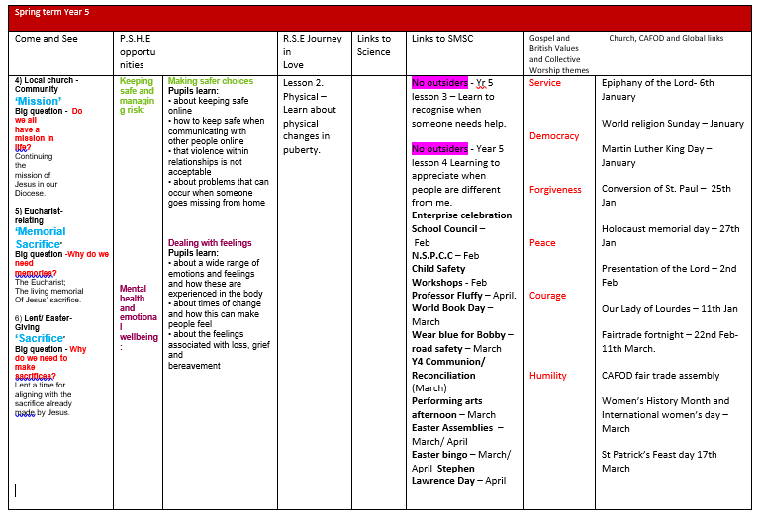

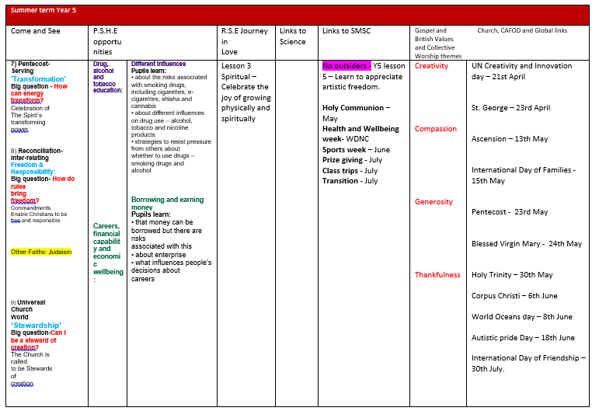

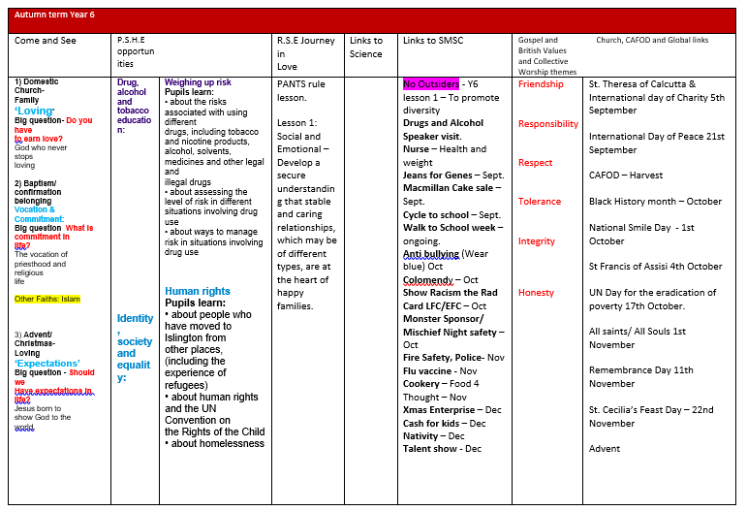

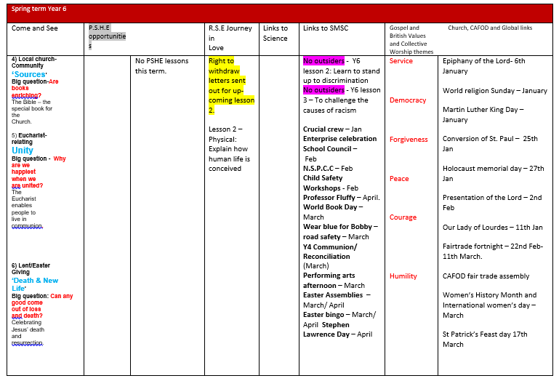

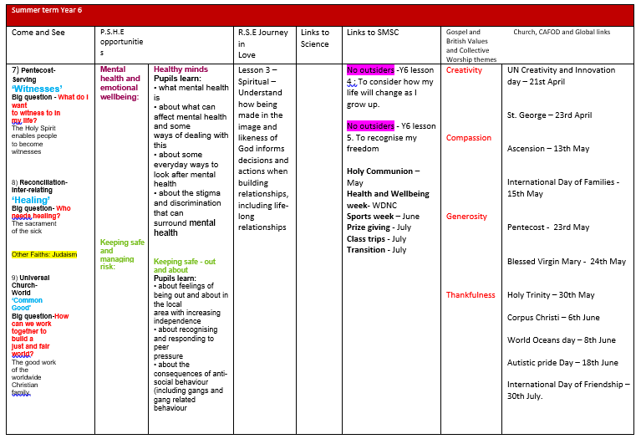

Appendix 2

Come and See and
Relationship and Sex Education
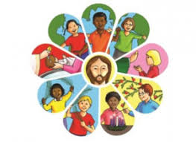
Introduction
The following is intended as a guide for linking Relationship and Sex Education with Come and See. Some of these aspects might be covered in the EXPLORE section where the topic is being introduced, starting with the pupil’s own experience, and extending into the REVEAL and RESPOND sections. Some ideas may be used in the REVEAL process where the teaching is explicitly concerned with Scripture and the teaching of the Church. Some topics offer more explicit teaching to develop ideas about Relationship and Sex Education, some less so.
Another way of using this section is when teaching Religious Education which occurs in other aspects of the curriculum e.g. Science, P.E, PSHE etc.
Year 3
HOMES | God’s vision for every family | - What makes a house a home  - What makes home a special place for you  - What makes a house a home  - Why is family important  - The respect of parents and children for one another  - What do you like to do at home, on your own and as a family  - What do people do for you at home, that makes you feel special  - What is sometimes difficult about sharing and being part of a group at home  - God’s dream for every family  - God is always there
PROMISES | The meaning of the commitment and promises made at Baptism | - What is good about being in a group  - Why we have rules  - The importance of making promises  - How some promises are more difficult to keep than others  - The link between the promises made the consequences of actions following the promise.  - The role of parents and godparents in bringing up the child in the Faith  - What it means to live a child of the Light
VISITORS | The coming of Jesus | - How we welcome visitors  - How we feel as a visitor  - The importance of preparing for visitors.  - The joys and demands of visitors
JOURNEYS | Christian family’s journey with Jesus | - Each year has its special times and seasons  - Life is a journey  - Who is with you on the journey  - What makes it good  - difficulties times in the life’s journey  - What/who helps  - How we help one another on the journey
LISTENING & SHARING | Jesus gives himself to us in a special way | - The cost of sharing  - The joys of sharing  - The importance of listening well and sharing.  - The joys and difficulties of listening and sharing  - How feelings affect our own and others desire to listen and to share.
GIVING ALL | Lent a time to remember Jesus’ total giving | - Why people are brave and give themselves to others  - The demands of total giving in terms of time and giving up something you what to do  - How people give themselves to others  - Those in need and how we might help them.  - Lent an opportunity for giving, growing in goodness.  - Jesus’ total giving
ENERGY | Gifts of the Holy Spirit | - The energy of wind and of fire.  - The best use of power of wind and fire  - The inspiration of the Holy Spirit  - The power and energy of the Holy Spirit  - The prayer to the Holy Spirit  - The gifts of the Holy Spirit  - Christians can use the gifts of the Holy Spirit to help others.
CHOICES | The importance of examination of conscience | - The meaning of choice and consequence  - The importance of making good choices  - What helps in making good choices  - Consequences of choices  - What it means to examine your conscience  - How God is always forgiving
SPECIAL PLACES | Special places for Jesus and the Christian community | - How places become special?  - What makes a place special?  - Special places for you and your family?  - Why is our heart a special place?  - Keeping our world a special place?  - Why do Christians want to keep the world a special pace?

YEAR 4
PEOPLE | The family of God in Scripture | - The importance of families  - Family relationships  - Respect for those who gave us life.
CALLED | Confirmation a time to renew baptismal promises | - Our response to being chosen  - What it feels like to be chosen  - Why it is difficult to make a response in some situations  - Giving up something else when you are chosen.  - What help do you need to chose  - The work of the Holy Spirit in our lives  - The work of the Holy Spirit in the lives of Christians  - What it is to live in the light of Christ  - The commitment of people who respond to the call of God
GIFT | God’s gift of love & friendship in Jesus | - What you value most about the gift of friendship  - What you offer others in your friendship  - Why the gift of love and friendship is important  - The joys and demands of friendship  - The commitment required by the gift of love and friendship.
COMMUNITY | life in the local Christian community: ministries in the parish | - The meaning of community  - The advantages of being part of a community?  - What helps to build up community  - The demands of being part of a community?  - Why people give time and service in helping others in their community  - The causes of a breakdown of a community  - How the parish community celebrates together and supports one another
GIVING & RECEIVING | Living in communion | - Your experience of giving and receiving.  - The importance of giving and receiving?  - The joys and demands of giving and receiving?  - Why it is important to live in communion  - Ways in which we live and grow in communion.  - How the Eucharist challenges and enables living and growing in communion?
SELF DISCIPLINE | Celebrating growth to new life | - The experience of giving up something and be very disciplined for a good reason.  - How to be self disciplined  - How self-discipline helps people to grow and make the best use of their potential  - Lent; the opportunity to make change and to prepare for Christ's Resurrection on Easter Sunday.
NEW LIFE | To hear & live the Easter message | - What you do when life is difficult  - The experience of good news bringing life. and happiness.  - How the power of the Holy Spirit helps Christians today
BUILDING BRIDGES | Admitting wrong, being reconciled with God and one another. | - What makes friendships strong  - How decisions about friendship are informed by beliefs and values.  - How friendships are built  - How friendships may be restored when they have been broken  - Sin and the importance of examining of your conscience  - The greatest commandment, love of God and others  - The meaning of contrition and of absolution  - Forgiveness of others
GOD’S PEOPLE | Different saints show people what God is like. | - What makes a person do extraordinary things?  - How ordinary people do extraordinary things.  - The qualities you admire in others  - How true happiness can be found  - How you can do extraordinary things

YEAR 5
OURSELVES | Created in the image and likeness of God | - Talents and qualities you admire in others  - Your own talents and qualities and how you use them  - Identify qualities in anyone else  - How talents and qualities are developed.  - We are made in the likeness of God  - What being unique means  - God’s love for us  - How Christians are called to live in peace.  - How people are made in God’s image and likeness might live
LIFE CHOICES | Marriage, commitment and service | - The ingredients of a good friendship  - What fidelity means and how it applies to friendship  - Responsibilities friends have for one another  - Difficulties and joys of friendships  - What is important for friendship to thrive  - What it feels like to have faithful friend  - Jesus’ advice about relationship?  - The importance of fidelity, loyalty and commitment in maintaining a friendship  - The importance of commitment and responsibility in relationships.  - What is means to be committed  - The work of Christian service  - The Sacrament of Marriage  - The symbols of the promises and the blessing of rings  - All are called to live in love and service
HOPE | Advent; waiting in joyful hope for Jesus; the promised one | - Your experience of waiting  - How people wait in different ways, for different things.  - Why waiting is a mystery  - How you can best use the time you spend waiting and what might help you  - What you think about when you are waiting for something exciting  - How you behave when you are waiting  - The difference between hope and expect  - Why people wait with hope  - The coming of Jesus at the end of time  - Advent is a time of waiting hopefully
MISSION | Continuing Jesus’ mission in diocese. [ecumenism] | - The demands and joys being dedicated in your mission  - Discovering your mission?  - What inspires people in their mission  - The joys and demands of engaging in a mission  - The reasons why people what to help others.  - How people carry out Jesus’ mission today  - Jesus’ prayer for unity
MEMORIAL SACRIFICE | The Eucharist; the living memorial of Jesus | - Why memories are important  - How it is possible to keep important memories alive  - About sacrifice in daily life
SACRIFICE | Lent a time of giving in order to celebrate the sacrifice of Jesus | - How you feel when you give  - How you feel when you refuse to give.  - The cost of giving.  - How people decide whether or not to give  - How those decisions are informed by beliefs and values  - The costs or rewards of giving can be  - That Lent is a season of giving to prepare for the Easter
TRANSFORMATION | Celebration of the Spirit’s transforming power | - How people can use the energy of their minds for the good of others.  - How people can use time and physical energy for the well being of others and why they should.  - How energy can transform  - How we can use our energy to transform ourselves  - How we can use the energy from the earth’s resources in a fair and sustainable way.  - How the power of the Holy Spirit helps Christians today
FREEDOM & RESPONSIBILITY | Commandments enable Christians to be free & responsible | - What freedom parents have a right to  - What freedom children have a right to.  - What is responsible and irresponsible behaviour.  - How rules can bring freedom  - How people know the boundaries that their personal freedom gives them.  - How freedom and responsibility are linked.  - How people’s perception of what their freedom allows may conflict with the expectation of others.  - How importance of the Ten Commandments for Christians today.  - How the Beatitudes show us a positive way of life.  - Jesus teaching on the greatest commandments, love of God and others.
STEWARDSHIP | The Church is called to stewardship of Creation | - What I really care about  - Showing concern for what I care for  - The meaning of stewardship  - Understanding the wonders of God’s creation  - People are made in the image and likeness of God  - Christians can be good stewards.  - The Christian’s responsibility to take care of, to be a steward of the earth  - The importance of ecology

YEAR 6
LOVING | God who never stops loving | - What unconditional love means  - How love is shown  - How you are loved and cared for  - What members of your family do for each other  - How you show love to others  - How people have inspired and influenced you to show unconditional love to others  - What it means to be truly loving  - How people show unconditional love to others  - The beliefs and values which have inspired and influenced you to be loving?  - The scripture text that demonstrate God’s unconditional love for everyone even when times are hard.  - The challenge these passages present to Christians.  - The Beatitudes and their meaning for today.  - God’s unconditional love and what this means.  - By living in God’s way, as Jesus showed us, we can grow in love.
VOCATION AND COMMITMENT | The vocation of priesthood and religious life | - What it means to be committed?  - Why people are committed?  - The implications of lack of commitment  - Whom shows commitment  - How commitment affects the level of job satisfaction  Responding to the call of Jesus  Our mission in living out our baptismal vows
EXPECTATIONS | Jesus born to show God to the world | - The expectations you have of yourself  - Having high expectations of others  - Trusting and believing in one another  - What happens if you let people down or others let you down?  - Patience is important in expectations  - The difference between wishing and expecting.  - The meaning of Advent
SOURCES | The Bible, the special book for the Church | - The kind of books which are the most helpful  - Our lives are enriched by books.  - The wonder of books and how they take a person beyond themselves  - The presence of God in the words of Scripture  - The care and reverence with which the Word of God is treated
UNITY | Eucharist enables people to live in communion. | - Why friendships are important  - The most important value in friendship  - What helps a friendship to flourish  - The kinds of behaviour that break a friendship  - Those affected when a friendship is broken  - Mending broken friendships  - Becoming one with Christ and one another in Holy Communion  - The unity which Holy Communion brings
DEATH & NEW LIFE | Celebrating Jesus’ death and resurrection | - The affect of loss in everyday life  - The change it brought  - What remained the same  - What is the best way to cope with loss  - How people cope with loss and death  - How death brings new life  - Lent, a time to remember the suffering and death of Jesus
WITNESSES | The Holy Spirit enables people to become witnesses | - When to be a witness  - How to be a witness  - Why it sometimes needs courage to be a witness  - Examples of modern witnesses  - The witness of a local charity,
HEALING | Sacrament of the Sick | Showing compassion and care for those who are ill  Our attitude towards those people are ill in their minds  Helping, caring and understanding those with a learning disability.  - What gives a person comfort when they are very ill  - Why people give time and commitment to caring for others  - Why we care for the sick  - The Sacrament of Anointing brings comfort to those who are sick  - The Christian responsibility for caring for these in need
COMMON GOOD | Work of Christians for the good of all | How we build a fair and just world  The difference between fairness and justice, unfairness and injustice  Helping to promote the dignity and common good of one another  Beatitudes; a guide from Jesus about how to live life.  - The ways we can act justly, love tenderly and walk humbly with God  - How Christians can work for the common good  - Something about Catholic Social Teaching

