St Cecilia’s Catholic Junior School
Spiritual, moral, social and cultural policy.

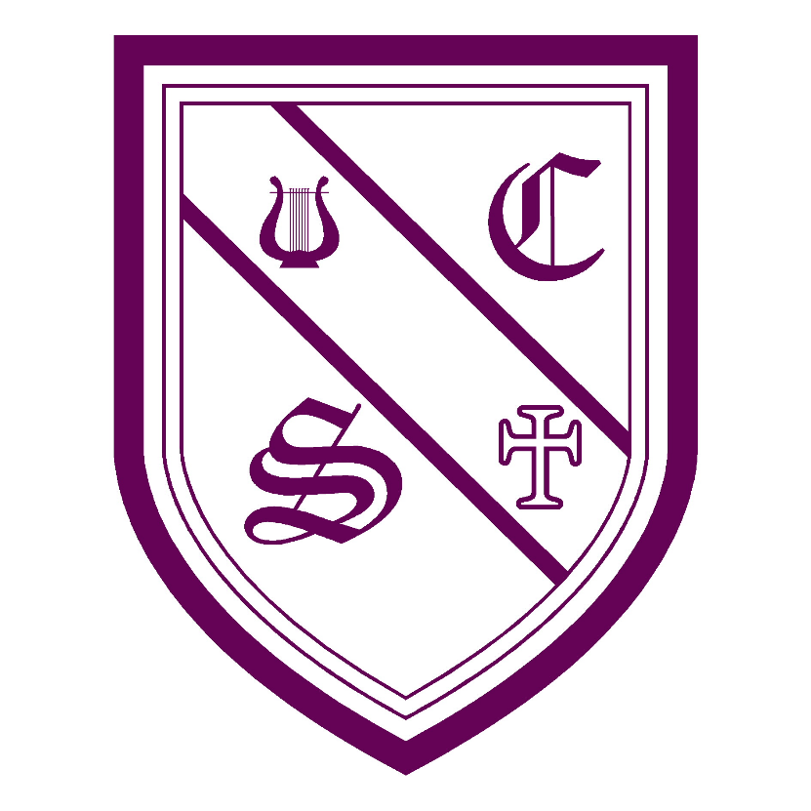

MISSION STATEMENT

Rooted in Gospel Values, St Cecilia’s Catholic School Community lives together, learns together and loves together.

Live:

We strive to be a community where everyone feels safe, secure and cared for, where all are respected and loved.

Learn:

We aim to provide an environment full of creativity, where talents grow and uniqueness is celebrated. We encourage co-operation and develop new experiences through exciting teaching methods.

Love:

We aim to create a school family where each person can experience the love of God. We seek to promote gospel values modelling Christian principles throughout our school community.

LOVE ONE ANOTHER, AS I HAVE LOVED YOU

This Policy is carried out within the context and spirit of the school’s Mission Statement. It supports and reinforces the aims of St Cecilia’s Catholic Junior School, valuing all children equally and as individuals encouraging them to grow together and reach their potential.

In contrast to the policies for specific curriculum subjects, this policy relates to the whole life of the school. Of particular importance in promoting spiritual, moral, social and cultural development (SMSC) is the example set by adults in the school, the quality of relationships and the standard of daily collective worship.

The statutory requirement that schools should encourage pupils’ Spiritual, Moral, Social and Cultural Development (SMSC development) was first introduced in the 1988 Education Reform Act.

The Act states that the curriculum for a maintained school must be a balanced and broadly based curriculum which:-

Promotes the spiritual, moral, social and cultural development of pupils at the school and of society; and

Prepares pupils for the opportunities, responsibilities and experiences of adult life.

The Revised National Curriculum stressed the importance of ensuring SMSC development is explored through other curriculum subjects:

All National Curriculum subjects provide opportunities to promote pupils' spiritual, moral, social and cultural development. Explicit opportunities to promote pupils' development in these areas are provided in Religious
Education and the non-statutory framework for Personal, Social and Health education (PSHE) at key stages 1 and 2. A significant contribution is also made by school ethos, effective relationships throughout the school, collective worship, and other curriculum activities.

At St Cecilia’s Catholic Junior School we believe that the planned promotion of the spiritual, moral, social and cultural development of our children is fundamental to the work of our school.

‘Catholics believe that Religious Education is not one subject but the foundation of the entire educational process. The beliefs and values it communicates should inspire and unify every aspect of school life. It should provide the context for and substantially shape the school curriculum and offer living experience of the life of faith in its practical expressions.’
Bishops of England and Wales, 1988

Our aim at St Cecilia’s Catholic Junior School is to create pupils who will Challenge, Change and Transform in their mission to build the Kingdom of God.

Spiritual development
Pupils' spiritual development involves the growth of their sense of self, their unique potential, their understanding of their strengths and weaknesses, and their will to achieve. As their curiosity about themselves and their place in the world increases, they try to answer for themselves some of life's big questions of purpose and meaning. They develop the knowledge, skills, understanding, qualities and attitudes they need to foster their own inner lives and non-material wellbeing. As a Catholic school, we place special emphasis on the specific teaching and beliefs of the Catholic faith, both within the daily life of the school and through the curriculum.

Moral development
Pupils' moral development involves pupils acquiring an understanding of the difference between right and wrong and of moral conflict, a concern for others and the will to do what is right. They are able and willing to reflect on the consequences of their actions and learn how to forgive themselves and others. They develop the knowledge, skills and understanding, qualities and attitudes they need in order to make responsible moral decisions and act on them. The system of rules and codes of behaviour established in our school is an important early introduction to issues of fairness for all and to the consequences of operating outside the accepted rule system. Pupils are encouraged to understand the need for a common code and to follow it from conviction rather than because of consequences or sanctions. Moral development, based on Christian principles, should enable pupils to become increasingly responsible for their own actions and behaviour.

Social development
Pupils' social development involves pupils acquiring an understanding of the responsibilities and rights of being members of families and communities (local, national and global), and an ability to relate to others and to work with others for the common good. They display a sense of belonging and an increasing willingness to participate. They develop the knowledge, skills, understanding, qualities and attitudes they need to make an active contribution to the democratic process in each of their communities. The school, but in particular the classroom, provides a suitable environment for promoting social development within a Christian context. Pupils learn to lead, to use their initiative and to use individual skills and strengths when working together towards a common goal. The ability to be led, to support others and to recognise the different skills of other group members can be developed when children work co-operatively and are influenced by their own spirituality and morality.

Cultural development
Pupils' cultural development involves pupils acquiring an understanding of cultural traditions and ability to appreciate and respond to a variety of aesthetic experiences. They acquire a respect for their own culture and that of others, an interest in others' ways of doing things and curiosity about differences. They develop the knowledge, skills, understanding, qualities and attitudes they need to understand, appreciate and contribute to culture. In order to make provision for cultural development existing knowledge, interests and experiences are strengthened and then built upon further. In this way pupils gain a deeper understanding of their own culture and the factors which influence it and gain a broader understanding of other cultures and cultural influences. All areas of the curriculum can be used to promote and develop cultural awareness, although the arts, music, dance, drama and art are those used more frequently. Culture gives expression to a community’s spirituality, morality and social values.

Aims for Spiritual Development
• the ability to listen and be still
• the ability to sense, the sacred, the Holy, the Divine
• the ability to reflect
• the ability to sense wonder and mystery in the world
• the ability to sense the special nature of human relationships

Objectives for Spiritual Development
• to develop the skill of being physically still, yet alert
• to develop the skill of being mentally still, concentrating on the present moment
• to develop the ability to use all ones senses
• to promote an awareness of and enjoyment in using one’s imaginative potential
• to encourage quiet reflection during a lesson or assembly
• to develop individual self-confidence in expressing inner thoughts in a variety of ways
• to consider the mystery of God and the wonder of his world
• to find an inner confidence and peace

Aims for Moral Development
• to understand the principles lying behind decisions and actions
• to be able to take moral decisions for themselves
• to assume moral responsibility through our Catholic beliefs and convictions
• to be able to distinguish between right and wrong
- to understand that out beliefs impact on our choices
- to treat everyone as equals as we are all made in the image and likeness of God

Objectives for Moral Development
• to tell the truth
• to respect the rights and property of others
• to keep a promise
• to help those less fortunate than ourselves
• to act considerately towards others
• to take responsibility for one’s own actions
• to exercise self-discipline
• to develop high expectations
• to develop positive attitudes
• to conform to rules and regulations for the good of all

Aims for Social Development
• to relate positively to others
• to participate fully and take responsibility in the classroom and in the school
• to use appropriate behaviour, according to situations based on our moral values
• to engage successfully in partnership with others
• to exercise personal responsibility and initiative
• to understand that, as individuals, we depend on family, school and society

Objectives for Social Development
• to share such emotions as love, joy, hope, anguish, fear and reverence
• to show sensitivity to the needs and feelings of others
• to work as part of a group
• to interact positively with others through contacts outside school, e.g. sporting activities, visits, Masses at Church, music festivals etc.
• to develop an understanding of citizenship and to experience being part of a whole caring community
• to show care and consideration for others by sharing and taking turns
• to realise there are things each person can do well
• to encourage each person to share their talents given by God

Aims for Cultural Development
The aims and objectives of cultural development relate to differing aspects of the word ‘culture.’
• to develop a sense of belonging to pupils’ own culture and being proud of their cultural background
• to express our spirituality and be proud of who we are, our rights and rituals
• to respond to cultural events
• to share different cultural experiences
• to respect different cultural traditions
• to understand codes of behaviour, fitting to cultural tradition

Objectives for Cultural Development
• to develop an awareness and recognition of what a ‘cultured person’ appreciates in terms of music, art, drama, literature etc
• to develop a love of learning
• to develop an understanding of British cultural tradition, including Catholicism
• to appreciate the values and customs of other ethnic and faith groups which make up modern British society, and the world beyond
• to develop the ability to value current cultural enthusiasms, icons, music and media, critically and independently of peer pressure

It is hoped that our children will develop a balanced approach to retaining the traditions of our Christian society, whilst perceiving in a positive light the contribution of other cultures, past and present

Provision for SMSC across the curriculum

Please see adaptations on Long Term Plans for each year group to see identified SMSC opportunities throughout the curriculum. Below are examples of how each subject will make a contribution to pupil’s SMSC development. These will be used to aid staff in their planning.

Religious Education makes a distinctive and substantial contribution to the delivery of SMSC:
• Learn about beliefs, values, and the concept of spirituality.
• Reflect on the significance of religious teaching in their own lives.
• Develop respect for the right of others to hold beliefs different from their own.
• Show an understanding of the influence of religion on society.
• Appreciation and understanding of different cultures, religions and traditions.

English makes a major contribution to pupils’ SMSC development through:
• Developing confidence and expertise in language, which is an important aspect of individual and social identity;
• Enabling pupils to understand and engage with the feelings and values embodied in high quality poetry, fiction, drama, film and television;
• Developing pupils’ awareness of moral and social issues in fiction, journalism, magazines, radio, television and film;
• Helping pupils to understand how language changes over time, the influences on spoken, and written language and social attitudes to the use of language.
• Using the Word of God to understand and engage with feelings and emotions.

Mathematics can provide a contribution to pupils’ SMSC by:
• Supporting whole school policy on issues such as discipline and behaviour.
• Enabling pupils to acknowledge the important contribution made to mathematics by non-western cultures.
• Encouraging the children in the ‘pursuit of truth’ when solving a problem/ investigation
• Enabling pupils to test information and sequences helping to unravel the mysteries of life.

Science provides opportunities for pupils’ SMSC development through examples such as:
• Encouraging pupils to reflect on the wonder of the natural world created by God
• Awareness of the ways that science and technology can affect society and the environment.
• to be considerate and empathetic to the moral dilemmas that can result in scientific developments.
• Showing respect for differing opinions, on creation for example.
• Co-operation in practical activity.
• Raising awareness that scientific developments are the product of many different cultures.
• to show Stewardship towards the world environment created by God

ICT can contribute to SMSC development by:
• Making clear the guidelines about the ethical use of the internet and other forms of communications technology.
• Acknowledging advances in technology and appreciation for human achievement.

History makes a contribution to SMSC by
• Looking at the establishment of multi-cultural Britain.
• Enabling pupils to reflect on issues that lack values of the Kingdom of God such as injustice during war.
• Showing an awareness of the moral implications of the actions of historical figures.

Design Technology makes a particular contribution to SMSC through:
• Reflecting on ingenious products and inventions, the diversity of materials and ways in which design technology can improve the quality of life.
• Awareness of the moral dilemmas created by technological advances, the impact of ‘winners & losers’ ethos.
• How different cultures have contributed to technology.
• Opportunities to work as a team, recognising others’ strengths, sharing equipment.

Geography contributes to SMSC where:
• Opportunities for reflection on the creation, earth’s origins, future and diversity are given.
• Reflection on the fair distribution of the earth’s resources.
• Studies of people and places gives pupils the chance to reflect on the social and cultural characteristics of society.

MFL contributes to SMSC through:
• Pupils may gain insights into the way of life, cultural traditions, moral and social developments of other people.
• Pupils social skills are developed through group activities and communication exercises.
• Listening skills are improved through oral/aural work.

Art may contribute to SMSC by:
• Giving pupils the chance to reflect on nature, their environment and surroundings.
• Studying artists with spiritual or religious theme, issues raised by artists which concerns ethical issues i.e. War and violence.
• to encourage pupil’s to focus on awe and wonder in God’s world

Music contributes to SMSC through:
• Teaching that encourages pupils to be open to the music of other cultures.
• Considering the role of music in society and to see how music can cause conflict and differences of opinion.
• Looking at the way music can change moods and behaviour.

Physical Education – Pupils’ SMSC development is actively promoted though PE by:
• Activities involving co-operation, teamwork, competition, rules, self-discipline and fair play.
• Exploring the sports and traditions of a variety of cultures.
• Individual activities that provide the opportunity for self-reflection, awareness and challenge.
• Enabling children to understand and celebrate how amazing and powerful the creation of the human body is.

PSHE - Much work takes place in assemblies (daily acts of collective worship), class discussions and
PSHE lessons, giving pupils opportunities to:
• Talk about personal experiences and feelings.
• Express and clarify their own ideas and beliefs.
• Speak about difficult events, e.g. bullying, death etc.
• Share thoughts and feelings with other people.
• Explore relationships with friends/family/others.
• Consider others’ needs and behaviour.
• Show empathy.
• Develop self-esteem and a respect for others.
• Develop a sense of belonging.
• Develop the skills and attitudes that enable pupils to develop socially, morally, spiritually and culturally —
e.g. empathy, respect, open mindedness, sensitivity, and critical awareness
Our weekly assembly themes are drawn from SEAL themes, religious festivals and world issues. The pre-planned music for assemblies provides a backdrop for pupils to reflect upon the themes.

Links with other policies
Other policies will be closely linked to SMSC development. E.g. Personal, Social and Health Education Policy; Behaviour Policy; Equal Opportunities Policy; Teaching and Learning Policy; RE Policy; SRE Policy; Prayer and Worship Policy; Individual Curriculum Policies

Role of co-ordinator
The co-ordinator has responsibility for overseeing the planning, the provision and the monitoring and evaluation of SMSC development. School life relating to S.M.S.C is accessed and monitored through the school recording system ‘Gridmaker’. The co-ordinator will keep in touch with national developments and will act in an advisory capacity, supporting colleagues. Staff meetings may be used for discussion and the update of information. Staff understand the impact that good spiritual, moral, social and cultural development can have on the school as a whole.

