With Jesus as our guide and walking by our side,
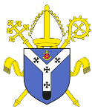
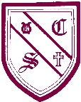
we learn to love and love to learn.
St. Cecilia’s Catholic Primary School
Religious Education Newsletter

Branch 2: Prophesy and Promise
Here is an overview of the second RE branch, Prophesy and Promise, which is being taught in the second half of the Autumn term. We encourage you to spend time talking with your child about what they have been learning and to support them with the suggested ‘Learning at Home’ activities. We would love to see these activities shared on our Instagram page: stceciliascps26.

EYFS
The children will know that Mary was chosen by God to be Jesus’ mother. They will learn that Mary and Joseph travelled to Bethlehem and that Jesus was born in a stable and laid in a manger. Children will know that the shepherds visited Jesus at the stable and that Advent is a time to get ready for Christmas. Finally, children will know that Jesus came for the whole world.

YEARS 1 AND 2
In Key Stage 1, children will understand that the Bible is a special book and encounter stories and accounts of how people came to know God and the Good News of Jesus in the Gospels. Children will sequence the accounts from the Annunciation through to the visit of the shepherds and know that the Annunciation is when God called Mary and she said, “Yes” to his call. Children will recognise that, for Christians, the Christmas story reveals God’s love by sending Jesus his son.

YEARS 3 AND 4
Children learn about the first part of the Mass. They will recognise and name some of the objects in a church and will understand why Catholics go to Mass. They will learn the structure of the Mass and name the different parts of the Liturgy. Children will learn about Advent and the signs and symbols that help Catholics live out this special season. They will learn about the Annunciation to Joseph and explore the meaning of the story.

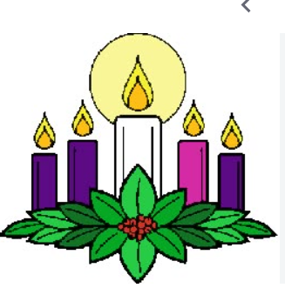
YEARS 5 AND 6
Children will reflect on the prophets Elijah and John the Baptist. For example, they will show some understanding of the cultural and religious context of Elijah’s time and why people needed to be reminded of God’s covenant. They will make links with the words of Isaiah, the preaching of John the Baptist and the season of Advent. Children will know that the feast of Christ the King marks the end of the Chruch’s year and describe what is celebrated, making links with the ancestry of Jesus and the Jesse Tree.

HOME LEARNING ACTIVITIES
- Watch https://bustedhalo.com/video/watch-advent-two-minutes together as a family and talk about the symbols used during Advent.
- Discuss how you make visitors to your home feel welcome.
- Create your own Advent wreath https://www.craftingjeannie.com/advent-wreath-craft-free-template/
- Create your own Advent calendar https://mamageek.co.uk/advent-calendar-boxes-free-printable/
We would love to see these activities shared on our Instagram page: stceciliascps26.

“I can do all things through Christ who strengthens me.” Philippians 4:13

